EVERYDAY CURRENT AFFAIRS – december 15, 2022
-

NATIONAL
- On December 14, Rajya Sabha - passed the Constitution (Scheduled Castes and Scheduled Tribes) Orders (Second Amendment) Bill, 2022
- The bill seeks to recognise the ‘Gond’ community in the Scheduled Tribes category across four districts of Uttar Pradesh with some amendments.
- The Bill seeks to amend the Constitution (Scheduled Castes) Order, 1950 and the Constitution (Scheduled Tribes) (Uttar Pradesh) Order, 1967
- The bill, which was passed by the Lok Sabha earlier this year and debated in the Rajya Sabha a day earlier, was passed by a voice vote in the Upper House.
- It amends the SC order to exclude Gond community as a Scheduled Caste in Chandauli, Kushinagar, Sant Kabir Nagar and Sant Ravidas Nagar districts of Uttar Pradesh and also amends the ST order to recognise the community as ST in these four districts

- The Assamese traditional scarf, “gamosa” - has received the Geographical Indication (GI) tag from the Geographical Indications (GIs) Registry

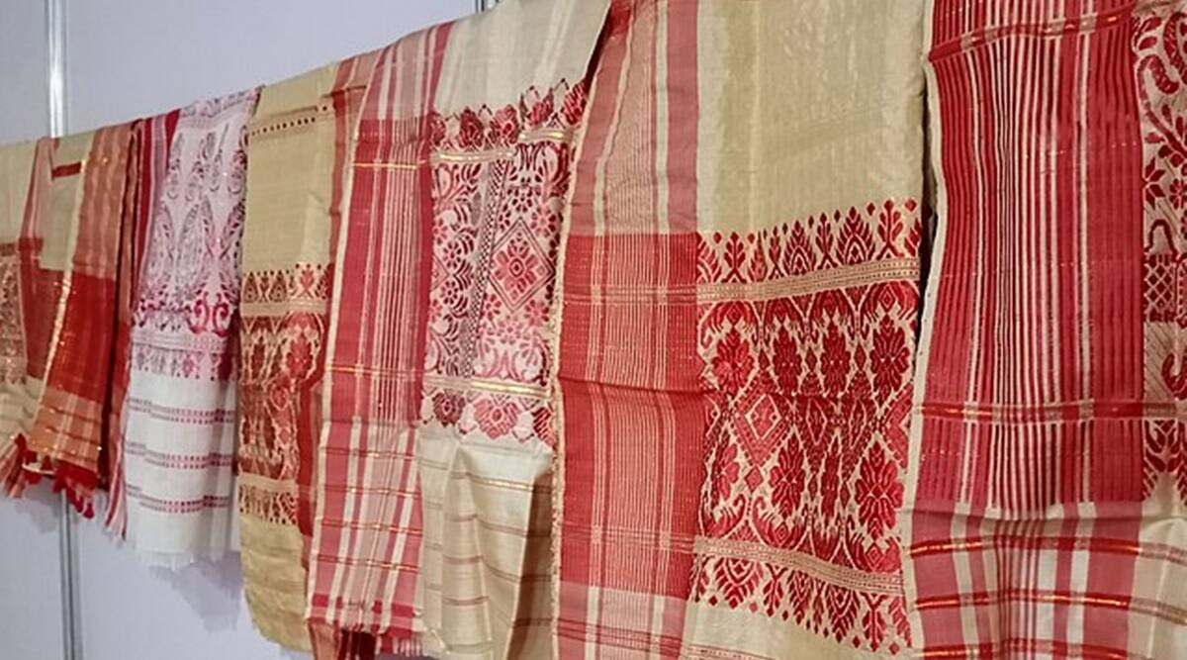

- The recognition comes five years after the claim was made by the state directorate of handloom and textiles.
- While gamosa became the 10th product or goods from Assam to get the GI tag, the total number of GI tags of India has gone up to 432.
- According to Union commerce and industry ministry, nine new items from various states of the country, including Assam’s gamosa, Tandur Redgram of Telangana, Raktsey Karpo Apricot of Ladakh, Alibag White Onion of Maharashtra etc.,were given the coveted GI tags
- Prime Minister Narendra Modi is among the distinguished personalities who are often seen with a gamosa, the unique identity of Assam, draped around their necks.
- While the traditional textile is a valuable property of Assam and kept in high esteem in social and cultural events, it is used to pay obeisance in Vaishnavite monasteries, temples and Bihu festivities.
- A pious occasion is considered incomplete without a gamosa in Assam.
- The top 5 states holding maximum number of GIs are Karnataka, Tamil Nadu, Uttar Pradesh, Karnataka and Kerala.

- The government - introduced the Multi-State Cooperative Societies (Amendment) Bill, 2022 in Lok Sabha on December 7
- The bill proposes merger of “any cooperative society” into an existing multi-state cooperative society.
- It was introduced in Lok Sabha by Minister of State for Cooperation B L Verma.
- As per the present law, enacted in 2002, only multi-state cooperative societies can amalgamate themselves and form a new multi-state cooperative society.
- The Bill also seeks to establish a “cooperative election authority” to bring “electoral reforms” in the cooperative sector
  - As per the proposed amendment, the authority will consist of a chairperson, a vice-chairperson and a maximum of three members to be appointed by the Centre.
- The Bill seeks to insert a new Section — 63A — in the principal Act relating to “establishment of the Cooperative Rehabilitation, Reconstruction and Development Fund” for revival of “sick multi-state cooperative societies”.
- It also proposes to insert a new Section — 70A — relating to “concurrent audit” for such multi-state societies with an annual turnover or deposit of more than the amount as determined by the Centre
- The bill establishes one or more cooperative Ombudsmen with territorial jurisdiction to inquire into the complaints made by the members of cooperative societies
- Another important change proposed in the existing law is increasing the monetary penalties on multi-state co-operative societies for the contravention of norms
- Provisions relating to representation of women and Scheduled Caste and Scheduled Tribe members in the board of co-operative societies have been included
- Further, co-opted directors with experience in the field of banking, management, cooperative management and finance will be appointed to promote professional management
INTERNATIONAL
- On December 14, the US military - formally launched a space force unit in South Korea

- This is its first such facility on a foreign territory and will likely to monitor its rivals North Korea, China and Russia.
- The U.S. Space Forces Korea is a subordinate of a bigger U.S. Space Force unit established within the Indo-Pacific command in Hawaii last month.
- The unit belongs to the US Space Force, which was launched in December 2019 under then-President Donald Trump as the first new US military service in more than 70 years.
- The Space Force will organize the defence of US interests in space — especially satellites used for civilian and military navigation, intelligence and communication.
SPORTS
- Argentina captain Lionel Messi – created multiple records in the first semi-final against Croatia at the FIFA World Cup 2022 on December 14.

- Messi became Argentina’s highest scorer in the World Cup with 11 goals in 25 appearances, surpassing Gabriel Batistuta, who had scored 10 goals during his 12 World Cup appearances.
- The Paris Saint-Germain star player had already surpassed Diego Maradona during the tournament for most goals
- Further, Messi matched legendary German footballer Matthaus' feat by recording his 25th appearance at the FIFA World Cup and will overtake him on December 18 in the FIFA World Cup 2022 final.
  - Messi and Matthaus hold the record for most appearances by a player at the FIFA World Cup.
  - Earlier, Messi was tied with Germany's Miroslav Klose with 24 appearances in the FIFA World Cup
- During the tournament, Messi joined the exclusive club of playing in five World Cup tournaments alongside Antonio Carbajal, Lothar Matthaus, Rafa Marquez, Andres Guardado and Cristiano Ronaldo.
- The Argentina talisman now has the most appearances (19) as captain at the FIFA World Cup
- Messi is the only player to register an assist in five World Cups after Pele, Grzegorz Lato, Diego Maradona and David Beckham, who set up goals in three editions each.

