EVERYDAY CURRENT AFFAIRS–june 1, 2023
-

STATES
- On May 31, Maharashtra Chief Minister Eknath Shinde - announced that the Ahmednagar district in the state will be renamed as ‘Ahilya Nagar’.
- The announcement comes on the birth anniversary of Ahilya Bai Holkar, the hereditary noble queen of the Maratha Empire, in early-modern India.
- The Maharashtra CM made the announcement at a function held to mark the 297th birth anniversary of Ahilya Bai Holkar at her birthplace, Chondi village in Ahmednagar district
- Ahilyabai Holkar, the 18th Century Holkar Queen of the Maratha Malwa kingdom, is known for building temples and 'dharamshalas' (public rest houses), throughout India.
- This is the third city in Maharashtra to be renamed in a year
- During February this year, the state government formally approved a proposal to rename Aurangabad as Chhatrapati Sambhajinagar and Osmanabad as Dharashiv.
- While Aurangabad was named after Aurangzeb, the Mughal ruler who killed celebrated Maratha king Shivaji’s son, Sambhaji, in 1689, Osmanabad was named after Mir Osman Ali Khan, the last ruler of Hyderabad.
- Located in western Maharashtra, Ahmednagar was named after Ahmad Nizam Shah I, the founder of the Nizam Shahi dynasty.
- The city has been a part of various kingdoms — including the Rashtrakutas, the Western Chalukyas, the Delhi Sultanate and the Deccan Sultanate.

- On May 30, the Maharashtra government - rolled out a new financial scheme under which more than one crore farmers in the state will be paid Rs 6,000 annually.
- The scheme, Namo Shetkari Mahasanman Yojana, was approved at a Cabinet meeting chaired by Chief Minister Eknath Shinde.
- The amount was in addition to Rs 6,000 paid to farmers in instalments per year by the Centre under the Pradhan Mantri Kisan Samman Nidhi Yojana.
- More than one crore farmers will benefit from the state government's new scheme
- Fadnavis, who is also the state's finance minister, had announced the scheme in the 2023-24 budget which he presented in the Assembly in March.
- The announcement by the Shinde government coincides with the completion of 9 years of the Narendra Modi government at the Centre
- The Pradhan Mantri Kisan Samman Nidhi (PM-KISAN) scheme was launched by PM Modi in 2019
- Under the scheme, in every four months period starting from April to July, August to November, and December to March of each fiscal year, the money is transferred to the farmers’ accounts in three equal instalments of Rs 2,000 each
NATIONAL
- On May 31, India - became the first country in the world to regulate anti-tobacco warnings on OTT platforms
- In this regard, the government has issued a notification that mandates health warnings in the programmes aired on OTT platforms
- Henceforth, publishers of online curated content that display tobacco products or their use will be required to display anti-tobacco health warnings
- These warnings should last a minimum of thirty seconds each at the beginning and middle of the programme.
- They should be exhibited as a prominent static message at the bottom of the screen during the display of tobacco products or their use.
- Furthermore, the health warning message and audio-visual disclaimer has to be in the same language as used in the curated content.
- The rules will come into force within three months from the date of its publication in the official gazette.

- On June 1, the Cabinet - approved a Rs.1 lakh crore plan to create the world’s largest grain storage capacity in India in the cooperative sector
- Under this scheme, a godown of a capacity of 2000 tonnes will be constructed in every block level through the Primary Agricultural Credit Societies (PACS)
- Currently, there are around 1 lakh PACS in the country, of which approximately 63,000 are operational.
- The new scheme aims to raise India's foodgrain storage capacity by 700 lakh tonne in the cooperative sector.
- Currently, the grain storage capacity in the country is about 1,450 lakh tonne.
- In the next five years, the storage capacity in the cooperative sector will expand to 2,150 lakh tonne.
- The move is aimed to reduce the damage of food grains due to a lack of storage, help in checking distress sales by farmers, reduce import dependence and create employment opportunities in rural India.
- The farmers, apart from storing their produce in the facilities, will also be able to get up to 70% loans from these societies.
- In order to ensure a time-bound and uniform implementation of the plan in a professional manner, the Ministry of Cooperation will implement a pilot project in at least 10 selected Districts of different States/ UTs in the country.
- Under the plan, an Inter-Ministerial Committee (IMC) will be constituted under the Chairmanship of Amit Shah, Minister of Cooperation and Home
  - Agriculture and Farmers Welfare Minister Narendra Singh Tomar, Consumer Affairs, Food and Public Distribution Minister Piyush Goyal, Food Processing Industries Minister Pashupati Kumar Paras and Secretaries concerned will function as members of IMC
  - The IMC will work towards converging existing schemes of the ministry of agriculture and farmers welfare, ministry of consumer affairs, food and public distribution, and ministry of food processing industries
  - The scheme would be implemented by utilizing the available outlays provided under the identified schemes of the respective Ministries
- One of the key advantages of this initiative is the creation of decentralized storage facilities at the local level, which will reduce food grain wastage and enhance the country's food security.
  - This will significantly reduce transportation costs incurred in the movement of food grains to procurement centres and subsequent transportation from warehouses to ration shops.
- India has 65,000 agricultural cooperative societies.
- India produces about 3,100 lakh tonne of foodgrains a year.
- The country's current godown facilities can store only up to 47% of the produce.
- On May 31, the Union Cabinet - approved the second phase of ‘City Investments to Innovate, Integrate and Sustain’ (CITIIS 2.0) to promote circular economy in 18 smart cities, which will be selected through a competition.
- The major focus of the programme will be on integrated waste management while it also aims at climate action.
- All 100 smart cities will be eligible for participation in the competition and the average cost of a project would be around Rs.90-100 crore.
- As per the decision, Rs.1,866 crore will be spent under this programme in the next four years.
- Different projects under this programme would include collection and transportation of waste, including transfer stations; automated recovery facilities; bio-methanation plants; construction and demolition waste processing plants; and sanitary landfills.

- The Indian cyber agency, Indian Computer Emergency Response Team (CERT-In) - has warned people about a dangerous Android virus called “Daam”
- This malware takes private information, gets around antivirus software, and the malware even puts ransomware on the systems it targets
- It has the ability to gain unauthorized access to various aspects of your phone, such as call records, contacts, browsing history, and even your camera.
- The virus typically transfers through third-party websites or applications downloaded from untrusted or unknown sources.
- Furthermore, it can take screenshots, steal text messages (SMSes), download and upload files, and transmit the stolen data to a command-and-control server.
- To protect yourself from such threats, the cybersecurity agency advises against visiting untrusted websites or clicking on untrusted links
INTERNATIONAL
- Iraq - has unveiled an ambitious $17 billion infrastructure project aimed at connecting Europe, West Asia, and Asia through a road and rail network.
- Known as the “Route of Development,” the regional transportation project will link the Grand Faw Port in southern Iraq to the Turkish border in the north.
- According to Iraq, this network will attract traffic away from Egypt’s Suez Canal and position itself as a crucial transportation hub in the region to facilitate the flow of goods from Asia to Europe
- The project involves the construction of high-speed trains capable of transporting both goods and passengers at speeds of up to 300 km per hour and the reconstruction of Iraq’s road network
INDIA AND NEIGHBOURS
- Nepal PM P K Dahal Prachanda - arrived in New Delhi for a four-day visit on May 31

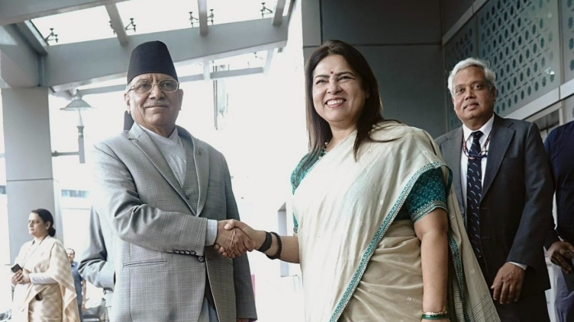

- This is his first visit abroad after taking over as Prime Minister in December last year
- The visit is aimed at enhancing cooperation in the energy sector and resolve outstanding issues like the border dispute.
- Prachanda will hold talks with his counterpart Narendra Modi on June 1, after which a number of agreements, including an energy pact, will likely be signed.
- The 68-year-old CPN-Maoist leader, who is visiting India for the third time as the Prime Minister, will also call on President Droupadi Murmu and Vice-President Jagdeep Dhankhar.
- Nepal is presently exporting over 450MW of electricity to India.
CONFERENCES & SUMMITS
- The Sovereign Wealth Fund Institute (SWFI) – has launched its Global Wealth Conference (GWC) on May 31 in London.
- During this two-day Conference, major investment decisions may take place for the Indian market.
- According to SWFI, a whopping $10 billion India-focused fund is to be launched at the conference.
- In 2022, the sovereign wealth funds directly invested $ 6.714 billion into India in 2022, compared to just $ 4.3 billion in 2021.
- Sovereign wealth funds include Mubadala Investment Company, Abu Dhabi Investment Authority, GIC Private Limited, Qatar Investment Authority, Kuwait Investment Authority and Norway Government Pension Fund Global.
PERSONALITIES
- Comptroller and Auditor General Girish Chandra Murmu - was re-elected with overwhelming majority as the external auditor of the World Health Organisation (WHO) from 2024 to 2027.

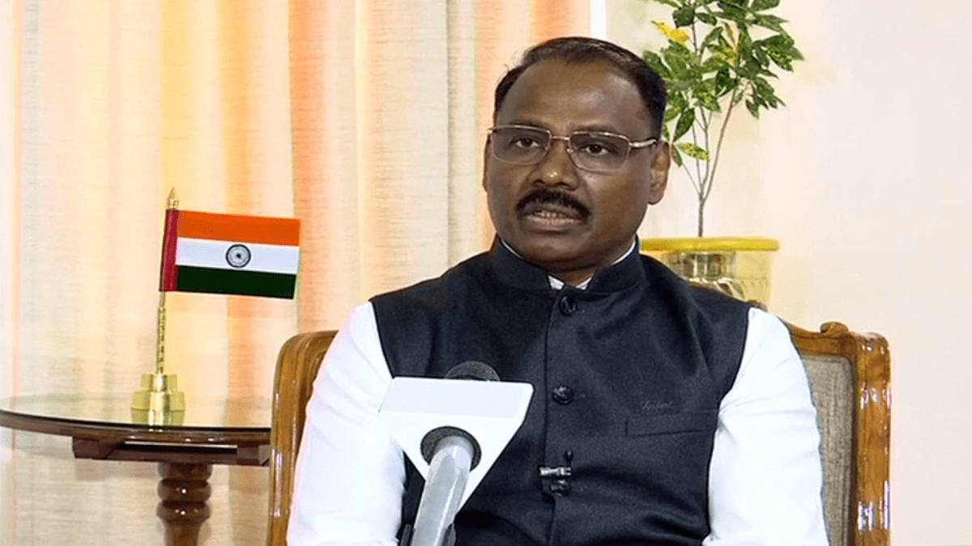

- He currently has this position for a four year term and will serve till 2023.
- The present election was held on May 29, 2023 in the 76th World Health Assembly in Geneva
- The CAG of India was re-elected after receiving an overwhelming majority of 114 votes out of 156 votes in the first round of voting itself, whereas only 79 votes are required for majority
- Before assuming office as the Comptroller and Auditor General of India on August 8, 2020, Murmu was the first Lieutenant Governor of the Union Territory of Jammu and Kashmir.
- Before his tenure at the Centre, Murmu had served in the Gujarat government and has a wide experience in administrative, economic and infrastructure fields.
- The re-election as WHO’s external auditor is his second major international audit assignment following his selection for the post of external auditor (2024-2027) of the International Labour Organization (ILO) in Geneva in March 2023.
- The CAG is a member of the United Nations Panel of External Auditors as well as the governing boards of the International Organization of Supreme Audit Institutions (INTOSAI) and ASOSAI.
- He chairs the INTOSAI Knowledge Sharing Committee, its working group on IT audit, and the Compliance Audit Sub-Committee.
DEFENCE
- Indian Air Force Chief Air Marshal V R Chaudhari – addressed the silver jubilee celebrations (1998-2023) of the India-Russia joint venture BrahMos Aerospace in Delhi.

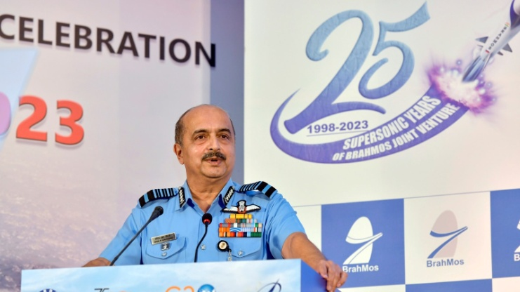

- According to the IAF Chief, the lethal combination of the BrahMos missiles, whose range has been extended to 450-km from the original 290-km, fitted on the Sukhoi-30MKI fighter jets has given a tremendous capability to enhance the country’s firepower
- The next generation BrahMos, a smaller and lighter version of the existing missile which flies almost at the speed of sound, will also be fitted into smaller fighters such as the MiG-29s, Mirage-2000s and Tejas light combat aircraft.
- An 800-kilometre range variant of the BrahMos has also undergone its maiden test.
- BrahMos is a supersonic cruise missile developed by the Russian-Indian joint company BrahMos Aerospace.
- The Russian NPO Mashinostroeniya and the Indian DRDO are the collaborative producers of the weapon.
- The BrahMos JV was formed through an inter-governmental agreement on February 12, 1998
- The JV was established with an authorised capital of US$ 250 million, with 50.5% contribution from the Indian side and 49.5% from the Russian side.
- The first successful launch of the missile took place on June 21, 2001 from a land-based launcher at the Interim Test Range off the Chandipur coast in Orissa.
- BrahMos Aerospace has received around 80 hectares of land in Lucknow, Uttar Pradesh for the establishment of the new manufacturing centre as part of the UP Defence Industrial Corridor (UPDIC) Project.
- The ship-based version of BrahMos was inducted in the Navy in 2005, the land-based version in the Army in 2007, and the air-launched version was inducted in the Air Force in 2020.
- The BrahMos II is set to be twice as fast as the BrahMos cruise missile, capable of exceeding Mach 6
- BrahMos-NG (Next Generation) is a smaller version of the existing BrahMos.
  - It will have the same 290 km range and Mach 3.5 speed as the existing BrahMos, while being 50% lighter and three meters shorter than its predecessor
BUSINESS/ECONOMY
- Fintech major Razorpay - has launched Turbo UPI in partnership with Axis Bank and the National Payments Council of India (NPCI).

- The new product will allow customers of online merchants to make UPI payments directly without getting redirected to a third-party UPI app during checkout.
- The new product comes after Paytm launched a similar product called "UPI SDK", a software plug-in that a merchant can integrate with their payment gateway.
APPOINTMENTS
- Praveen Kumar Srivastava - was sworn in as the Central Vigilance Commissioner on May 29.

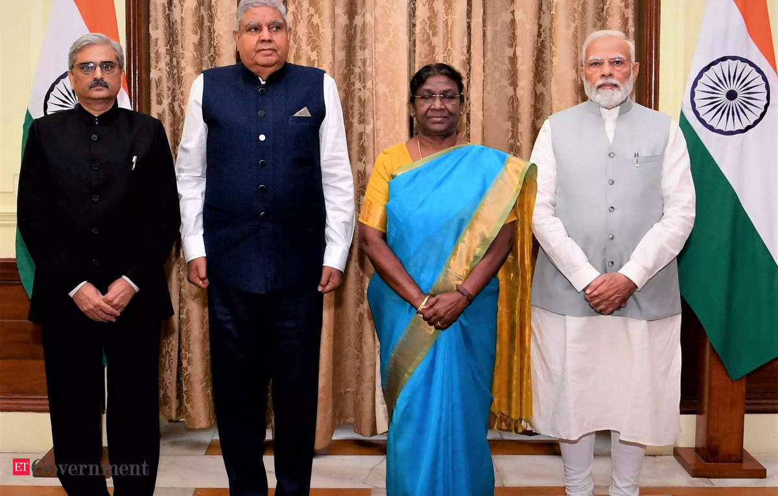

- President Droupadi Murmu administered the oath of office to him at Rashtrapati Bhavan.
- The ceremony was attended by Vice President Jagdeep Dhankhar and Prime Minseter Narendra Modi among other dignitaries.
- Srivastava is a 1988-batch retired Indian Administrative Service officer of the Assam-Meghalaya cadre.
- He superannuated as secretary (Coordination), Cabinet Secretariat on January 31 last year.
- He also served as Chief Vigilance Officer in RITES Ltd and as joint secretary and Mission Director, Jawaharlal Nehru National Urban Renewal Mission (JNNURM).
- Srivastava was working as the acting Central Vigilance Commissioner (CVC) since December last year after completion of Suresh N Patel’s tenure as the CVC
- The Vigilance Commission is headed by a CVC and can have a maximum of two vigilance commissioners.
- The tenure of a CVC and the vigilance commissioner is of four years or till the incumbent attains the age of 65 years.
- Former Intelligence Bureau (IB) chief Arvinda Kumar is the lone vigilance commissioner.
INTERNATIONAL DAY
- The Indian Army - commemorated the 75th International Day of UN Peacekeepers by paying homage to the fallen heroes on May 29
- The Chief of the Army Staff, Vice Chief of Army Staff and representatives from the Indian Navy and the Indian Air Force, Ministry of External Affairs and the United Nations laid wreaths at the National War Memorial, New Delhi.
- It was on this day in 1948 that the first UN peacekeeping mission, “UN Truce Supervision Organisation (UNTSO)” began operations in Palestine.
- This year marks the 75th Anniversary of the UN Peacekeepers Day, which is observed with the theme “Peace begins with me”

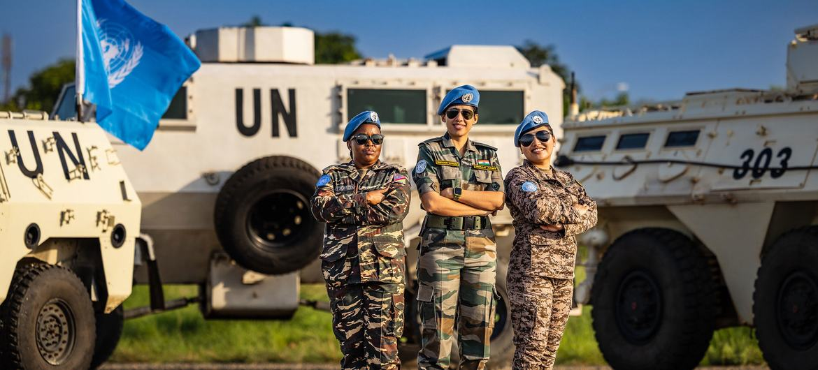

- Earlier on May 25, three Indian peacekeepers were honoured with the UN's Dag Hammarskjold Medal for supreme sacrifice
- India has a rich legacy of contribution to UN Peacekeeping operations and is one of the largest contributors of troops.
- From Congo to Liberia to South Sudan, India has deployed more than 3 lakh troops as peacekeepers in over 51 UN peacekeeping missions.
- Additionally, India was the first nation to send an all-female contingent to a UN peacekeeping operation in Liberia in 2007.
- India has pledged one Infantry Battalion Group and a corvette with helicopter as ‘hard power’ and an Engineer Company and Signal Company as ‘force enablers’ to be deployed at the behest of the UN.
- The Indian Army has established a Centre for UN Peacekeeping (CUNPK) in New Delhi to impart niche training in peacekeeping operations.

