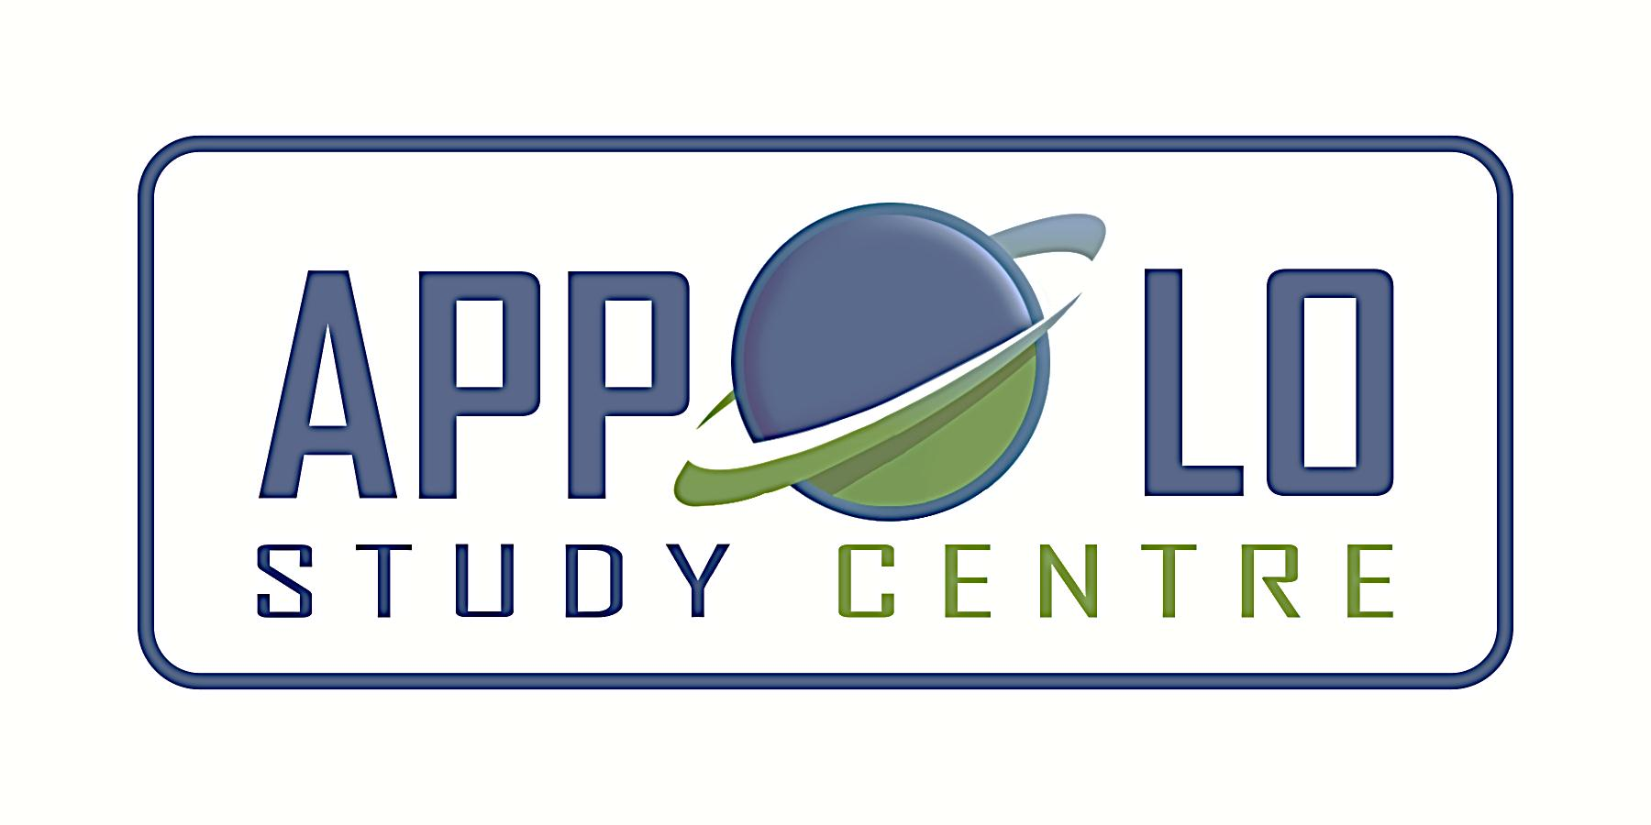
EVERYDAY CURRENT AFFAIRS – DECEMBER 17, 2021
-

TAMIL NADU
- Chief Minister M K Stalin - inaugurated the urban square spread over nearly 5.9lakh sqft beneath the cloverleaf-shaped Kathipara flyover in Chennai on December 16.

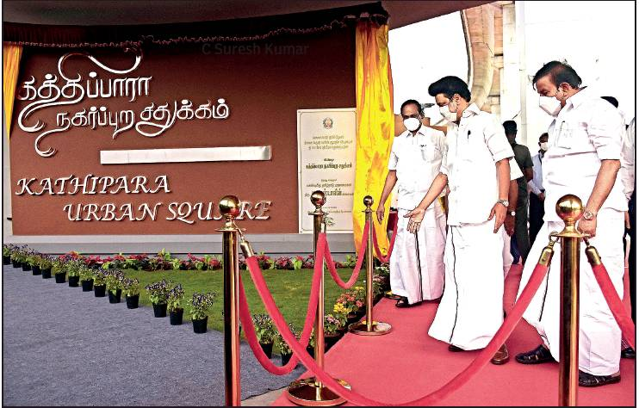

- The project was developed by the Chennai Metro Rail Limited (CMRL), with funds from the Chennai Metropolitan Development Authority (CMDA)
- The urban square, built at a cost of ₹14.5crore, will primarily serve as a rest stop for those arriving at the city.
- The square divided into four zones will be easily accessible to people arriving from Meenambakkam and airport, Porur, Ekkattuthangal and Guindy.
- Other amenities at the square include eight bus stops for MTC, a parking lot that can accommodate 128 cars and 340 two-wheelers, crafts bazaar, shopping area and children play area.
- The space also has an installation of Tamil vowels that can serve as backgrounds for selfies.
- The contract for the construction and maintenance of the square was given to BNR Infrastructure, a Chennai-based private company
- In a release, the state government called the urban square a milestone in Singara Chennai 2.0 project.

- The Tamil Nadu government - has sanctioned ₹352.5 crore towards the implementation of Member of Legislative Assembly Constituency Development Scheme (MLACDS) – fully funded by the state government -- for this fiscal year.
- This is 50% of the ₹702 crore allocated in the budget for the current year.
- Each MLA is entitled to get ₹3 crore to implement the listed schemes in their constituencies.
- The director of Rural Development and Panchayat Raj is authorised to draw the amount sanctioned and disburse the same to the district collectors and the commissioner of Greater Chennai Corporation
- Due to the Covid-19 pandemic, the previous AIADMK government reduced the per MLA allotment to ₹2 crore during 2020-21.

- A team of Archeological Survey of India (ASI) officials – have discovered a 5th century stone sculpture of Vinayaki, (female form of Lord Ganesha), from the pre-Pallava period

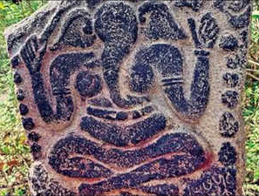

- The three-ft-tall sculpture on a granite stone was located at a village in Chengalpet district, about 100 km south of Chennai
- The discovery is a rare antique piece comprising details of the donor inscribed in early Tamil script.
- While Vinayaka (Lord Ganesha) is worshiped widely in Tamil Nadu, there are very few idols of Goddess Vinayaki with a trunk.
- The inscriptions are early Tamil scripts that can be traced to about 1,500 years ago.
- Vinayaki, the female form of Lord Ganesha, is largely worshiped in North India and is very rare in the south, particularly in Tamil Nadu
NATIONAL
- The Union Cabinet – has cleared the proposal to increase the minimum legal age of marriage for women from 18 to 21, bringing it on par with men
- Following the Cabinet’s approval, the Government will introduce an amendment to the Prohibition of Child Marriage Act, 2006, and consequently bring amendments to the Special Marriage Act and personal laws such as the Hindu Marriage Act, 1955
- The Union government is planning to bring a bill in this regard in the ongoing winter session of Parliament
- Prime Minister Narendra Modi, during his Independence Day speech last year, had made a mention of the proposal.
- The proposal is based on recommendations submitted to Niti Aayog in December 2020 by the Centre’s task force, headed by Jaya Jaitly, the former president of Samata Party
- The task force, set up in June 2020 by the Ministry of Women and Child Development, also included Dr V K Paul of Niti Aayog and Secretaries of the WCD, Health and Education ministries and of the Legislative Department, apart from academicians Najma Akhtar, Vasudha Kamat and Dipti Shah.
- It was constituted to examine “matters pertaining to age of motherhood, imperatives of lowering MMR (Maternal Mortality Rate), improvement of nutritional levels and related issues”
- The Section 5(iii) of the Hindu Marriage Act, 1955 sets 18 years as the minimum age for the bride and 21 for the groom.
- The Special Marriage Act, 1954 and the Prohibition of Child Marriage Act, 2006 also prescribe 18 and 21 years as the minimum age of consent for marriage for women and men, respectively.
- Women’s age of marriage was increased from 15 years to 18 years in 1978, by amending the erstwhile Sharda Act of 1929.
- As many as 23.3% of women aged 20-24 were married before they turned18, the legal age of marriage, as per National Family Health Survey-5 (2019-21).
- The latest survey shows the problem is more prevalent in rural India at 27% whereas in urban regions, underage marriage accounted for 14.7% of all marriages.

- The joint parliamentary committee on personal data protection - has submitted its final report in Parliament on December 16
- Congress Member of Parliament Jairam Ramesh extended the JPC report in the Rajya Sabha while BJP MP PP Chaudhary, the chairperson of the panel, tabled the report in the Lok Sabha
- The Personal Data Protection Bill, 2019, was introduced in Lok Sabha on December 11, 2019 by the then Union Minister of Electronics and Information Technology, Ravi Shankar Prasad
- It seeks to provide for protection of personal data of individuals, and establishes a Data Protection Authority (DPA)
- The Bill, which contains 98 clauses, was referred to the joint committee headed by BJP MP Meenakshi Lekhi in December 2019.
- Lekhi was replaced as chairperson by another BJP MP, PP Chaudhary, after she became the minister in Union cabinet in July 2021
- The proposal for the Bill came after the Supreme Court declared in 2017 privacy a fundamental right and directed the government to come up with the data protection regime.
- The JPC’s report on the Personal Data Protection Bill, 2019, recommends wide ranging changes including widening the scope of the Bill to include non-personal data
- It has reintroduced a recommendation of heavy penalties for serious data violations with fine up to ₹15 crore, or 4% of global turnover, while lesser violations will have a limit of ₹5 crore, or 2% turnover.
- The committee has expressed concerns about the safety of the SWIFT network, which enables international financial transactions between banks
- It has recommended that an alternative indigenous financial system be developed along the lines of similar systems elsewhere, such as Ripple (USA) and INSTEX (EU), to ensure privacy while also boosting the digital economy.
- The JPC recommended a 24-month period after the notification of the Act for the appointment of the chairperson and members of the DPA.

- Bengal’s biggest festival ‘Durga Puja of Kolkata’ – enters into the UNESCO’s the representative list of Intangible Cultural Heritage of Humanity

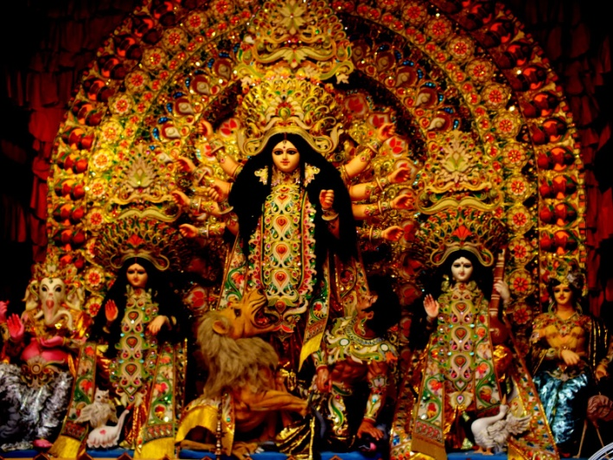

- The decision to include Durga Puja as a World Heritage site was taken during the sixteenth session of the annual convention of UNESCO's Intergovernmental Committee for the Safeguarding of Intangible Cultural Heritage held online in Paris from December 13 to December 18
- This is the first festival in Asia to receive the recognition.
- Durga Puja joins other Indian cultural practices and expressions, such as Kumbh Mela, Chhau dance from Bengal and Odisha, Sankirtana from Manipur, Yoga, Ramlila, Buddhist chanting in Ladakh and Nawruz on the ICH list.
- The recognition as a world heritage will not only attract more international tourists to Kolkata and Bengal, but will also lead to foreign investment in the festival
- An annual festival, Durga Puja marks the ten-day worship of goddess Durga which involves sculptures of the goddess sculpted from clay pulled from the Ganga
- Apart from Kolkata, the festival is also celebrated in Tripura, Bihar, Jharkhand, Odisha, Assam, Maharashtra, Delhi, and Uttar Pradesh
- Since 2016, the West Bengal government has been organising a Durga Puja Carnival, a parade of popular pujas from Kolkata and adjoining districts along with cultural performances
- Apart from the Kolkata Durga Puja, the Saint John celebrations in Venezuela, the Corpus Christi festival celebrated in Panama and the Bolivian Grand Festival of Tarija were also included in UNESCO's list of 'Intangible Cultural Heritage of Humanity'.
- The Representative List of the Intangible Cultural Heritage of Humanity currently has 492 elements.
- The list of Intangible Cultural Heritage elements on the UNESCO website includes 13 entries from India.
- Besides Durga Puja in Kolkata (2021), the India list includes Kumbh Mela (2017); Nowruz (2016); traditional brass and copper utensil-making among the Thatheras of Jandiala Guru, Punjab (2014); Sankirtana of Manipur (2013); Buddhist chanting of Ladakh (2012); Chhau dance, Kalbelia dance of Rajasthan, and Mudiyettu of Kerala (2010); Ramman festival of Garhwal (2009); and Kutiyattam Sanskrit theatre, Ramlila, and Vedic chanting (2008).
APPOINTMENTS
- Army chief General M M Naravane - is now acting as the chairman of the chiefs of staff committee (CoSC).

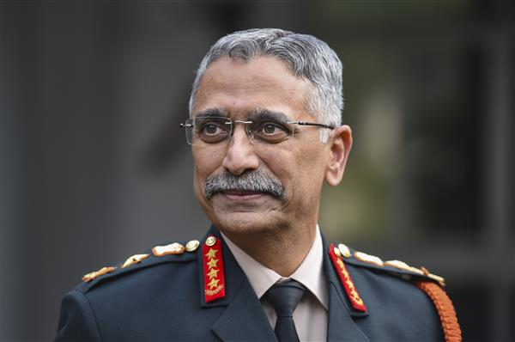
- Chief of defence staff (CDS) General Bipin Rawat passed away on December 8 following the chopper crash in Coonoor, Tamil Nadu
- As per the earlier system, the senior-most among the Army, Navy and IAF chiefs would be the CoSC chairman
- Gen Naravane took over as the Army chief from Gen Rawat on December 31, 2019
- He is slated to retire in April next year and is considered to be the frontrunner for the post of CDS
- Air Chief Marshal Vivek Ram Chaudhari took over as the IAF chief on September 30 this year.
SPORTS
- On December 16, Indian shooter Avani Lekhara - won the “Best Female Debut” honour at the 2021 Paralympic Awards for her record-breaking gold medal at the Tokyo Games.

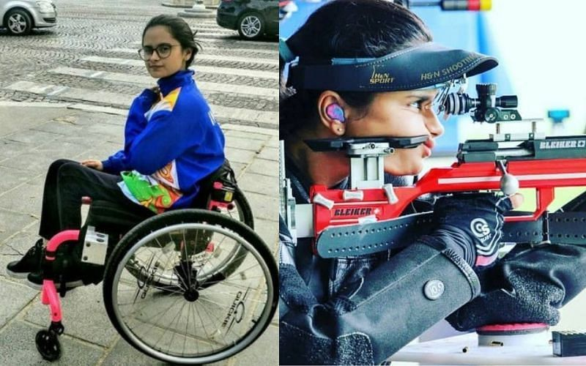

- The 20-year-old from Jaipur, who sustained spinal cord injury in a car accident in 2012, won the gold in the women’s 10m Air Rife Standing SH1 event earlier this year.
- With that special feat, Avani had broken the Paralympic Games record besides equalling the world record
- Avani was the first-ever female Paralympic gold medallist from India
- She also won a bronze in the 50m Rifle Three Positions Standing SH 1 event, becoming the first Indian female to win two medals in Games’ history on September 3, 2021
- It was also India’s first Paralympic medal in shooting.
- Avani was also awarded Major Dhyan Chand Khel Ratna, India’s highest sporting honour, for her achievement.
- India won an unprecedented 19 medals at the Paralympic Games including five gold, eight silver and six bronze
- Dutch wheelchair tennis player Diede de Groot and Swiss wheelchair Racer Marcel Hug are among the winners of the 2021 Paralympic Sport Awards as announced by the International Paralympic Committee (IPC) on December 16, 2021
- De Groot became the first Wheelchair Tennis player to complete the calendar Golden Slam by winning all four Grand Slam titles and the Paralympic gold medal
- The awards recognise achievements from the Tokyo 2020 Paralympic Games across seven categories - Best Female, Best Male, Best Female Debut, Best Male Debut, Best Team, Best Official, and BP Courage Award.
KASHI VISHWANATH DHAM CORRIDOR - REPORT

