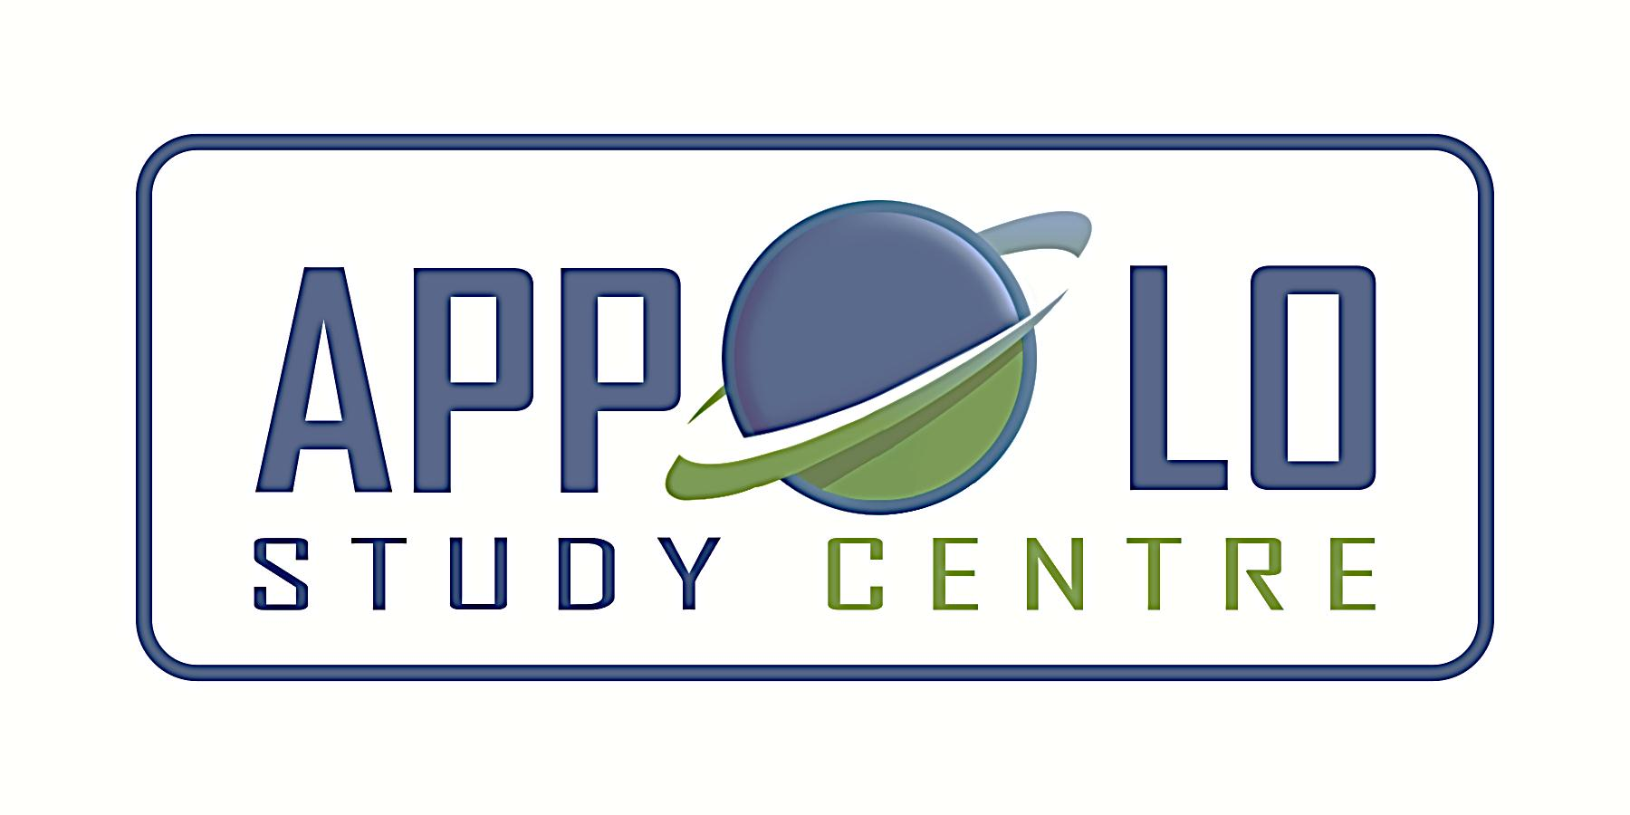
EVERYDAY CURRENT AFFAIRS –jUNE 26, 2021
-

TAMIL NADU
- Greater Chennai Corporation - won two awards at the Smart Cities Mission’s sixth anniversary award contest ‘ISAC-2020 – Indian Smart Cities Award Contest’
- The civic body has not bagged any awards in the last two years
- The first award is for the lake rejuvenation project under the urban environment category and the second award is for innovation in the Covid-19 response.
- Another positive development is that Chennai has risen from 42nd to 14th spot in weekly rankings.
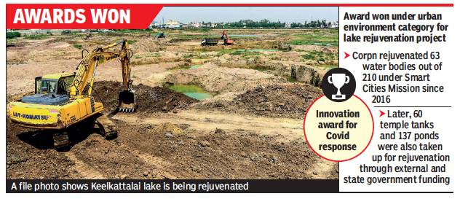

- Overall, Tamil Nadu won about six awards including the state award for third best smart city in the country, after Uttar Pradesh and Madhya Pradesh
- Under the Covid response category, Chennai bagged the award for setting up 19 tele-counselling centres and for launching corona monitoring app, vidmed and home quarantine and isolation management system to curb the spread of the virus.
- The Smart Cities Mission has been given an extension until 2023 for completion of its projects by the Centre.
- So far, Chennai has spent about ₹599 crore and has completed 37 projects, while eight projects worth ₹352 crore, are in progress.
STATES
- The West Bengal Cabinet - approved the “Student Credit Card scheme” on June 24, 2021.
- This was announced by the State Chief Minister Mamata Banerjee
- Trinamool Congress had promised to launch this scheme in its election manifesto.
- Under the scheme, a student can get a soft loan of up to Rs 10 lakh to do higher studies with the help of the credit card
- The benefits under the scheme is applicable to anyone who has spent 10 years in West Bengal and below the age of 40 years
- Loan will be available for undergraduate, postgraduate, doctoral and post-doctoral study in India or abroad, at an interest rate of 4%
- The student will have 15 years to repay the loan after obtaining it
- The programme will be launched on June 30, 2021
- Earlier, Bihar government has launched “Student Credit Card Scheme” on October 2, 2016.
- Under this scheme, interest free loan of up to Rs. 4 lakh is being provided to the poor Class XII pass students of Bihar state to enroll into higher education.

- The International Bank for Reconstruction and Development (IBRD) - had sanctioned ₹1,860 crore funds for implementation of ‘Supporting Andhra's Learning Transformation’ (SALT) programme
- The programme aims to improve learning outcomes, quality of teaching practices and school management in basic education
- It seeks to transform government schools into competitive institutions.
- Under the scheme, the State is implementing initiatives like Mana Badi Nadu-Nedu, as part of which the infrastructure facilities in Government schools across the state are developed extensively.
- The scheme proposes curriculum reforms, improved classroom practices, professional development of teachers and preparing students to be globally competitive by introducing English as a medium of instruction in Government schools in the state
- It will be implemented as a five-year-long project from the academic year 2021-22 to 2026-27
- Washington-based IBRD is an international financial institution, which is the lending arm of World Bank Group

- The Department of Women & Child Development in Kerala - has announced the expansion of ‘Kaval Plus’ programme to five more districts, after the success of the pilot project in two districts
- Kaval Plus is an ambitious state scheme for supporting children in need of care and protection and survivors of sexual abuse
- It has been launched in Thiruvananthapuram and Palakkad districts in December 2020 and supported nearly 300 and 150 children respectively, till now
- The programme is now expanded to Ernakulam, Idukki, Malappuram, Kozhikode, and Kannur districts
- The project is being implemented with the help of NGOs experienced in working with the children along with the child protection agencies

- The World Bank, the Mizoram Government and the Central Government - signed a $32 million loan agreement for Mizoram Health Systems Strengthening Project
- The project seeks to improve the capacity and quality of health services in the state of Mizoram
- The funding will strengthen the governance and the management structure of the Department of Health and Family Welfare (DoHFW) and its subsidiaries in the State
- The Mizoram Health Systems Strengthening Project will benefit the people across all eight districts of the state
- The project will assist in improving the overall ecosystem for bio-medical waste management (both solid and liquid waste).
- The funding will also be used to strengthen the effectiveness of the state health insurance programme and integrate the centre’s Pradhan Mantri Jan Arogya Yojna (PMJAY)

NATIONAL
- Surat (Gujarat) and Indore (Madhya Pradesh) - have bagged the best award for their overall performance among 100 smart cities in 2020
- Uttar Pradesh won the best award in the category of states, followed by Madhya Pradesh and Tamil Nadu.
- This is for the third consecutive time that Surat has won the award since the rankings were launched in 2018.
- This is the first time the housing and urban affairs ministry has given awards to states for the overall performance of their smart cities and for their proactive role.
- Uttar Pradesh bagged the first award for taking up development of seven more cities on its own as smart cities. in addition to the 10 that were selected by the Centre.
- The seven cities are Meerut, Ghaziabad, Ayodhya, Firozabad Gorakhpur, Mathura-Vrindavan and Saharanpur.
- The third edition of the awards was announced by housing and urban affairs minister Hardeep Singh Puri on June 25.
- The awards were given across the themes of social aspects, governance, culture, urban environment, sanitation, economy, built environment, water and urban mobility among others.
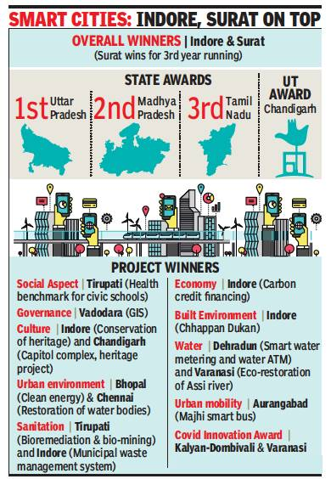

- Further, new themes were also added this year for sustainable business model of Integrated Command and Control Centres and innovation in Covid management.
- The joint winners under Covid innovation category were Kalyan-Dombivali in Maharashtra and Varanasi in UP.
- The awards commemorated six years of the Union government’s three initiatives to improve urban development - Smart Cities Mission (SCM), Atal Mission for Urban Rejuvenation and Urban Transformation (AMRUT), and Pradhan Mantri Awas Yojana-Urban (PMAY-U).
- These schemes were launched by Prime Minister Narendra Modi on June 25 in 2015
- Chandigarh was ranked first among union territories, while Indore won the Innovative Idea Award for its ‘Carbon Credit Financing Mechanism’
- Ahmedabad bagged the Smart Cities Leadership Award, followed by Varanasi and Ranchi in the second and third spots respectively
- The top nine performing cities awarded a four-star rating are Surat, Indore, Ahmedabad, Pune, Vijayawada, Rajkot, Visakhapatnam, Pimpri-Chinchwad and Vadodara.
- According to the ministry, out of the total proposed projects under the mission, 5,924 projects worth Rs 1.78 lakh crore have been tendered so far
- Further, work orders have been issued for 5,236 projects costing a budget of Rs 1.46 crore.
- A total of 2,665 projects of Rs 45,080 crore have also been fully completed and are operational.
- Under the mission, 70 smart cities have set up, which have already operationalised their Integrated Command and Control Centres
- These Centres also function as war-rooms for Covid management
- According to the ministry, under PMAY (Urban), about 1.12 crore houses have so far been sanctioned for beneficiaries, of which more than 83 lakh homes are grounded and over 50 lakh completed.
- Around 105 lakh household tap water connections and 78 lakh sewer or septage connections have so far been provided under AMRUT scheme and in convergence with other schemes

- Prime Minister Narendra Modi - interacted with participants of Toycathon-2021 through video conferencing on June 24, 2021

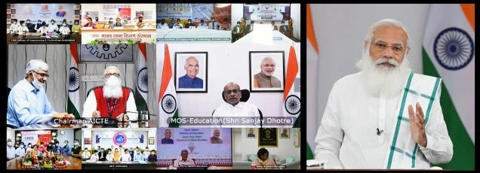

- A total of five teams presented their unique toy and gaming ideas during the live video conference.
- The winners of the contest will receive prizes worth Rs 50 lakh
- Union minister of education Ramesh Pokhriyal was also present on the occasion.
- Union Minister Women and Child Development and Textiles Smriti Zubin Irani and Minister of State for Education Sanjay Dhotre virtually inaugurated Toycathon 2021 grand finale on June 22
- Toycathon 2021 was jointly launched by the Ministry of Education, WCD Ministry, MSME Ministry, DPIIT, Textile Ministry, I&B Ministry and AICTE on January 5 this year to crowd-source innovative toys and games ideas.
- The Ministry of Educations Innovation Cell and the All India Council for Technical Education are the organizing agencies for this Inter-ministerial Toycathon.
- Around 1.2 lakh participants from across the nation have registered and submitted more than 17000 ideas for the event
- Out of this, 1,567 ideas have been shortlisted for the ‘online’ Toycathon grand finale, being held from June 22-24
- Toycathon 2021 is aimed at boosting the toy industry in the country to help it capture a wider share of the toy market.
- Globally, toy-making is a $100 billion industry, with China, the USA, Germany and Japan being the key players.
- India imports 80 to 85% of its annual $1.5-billion toy market.

- The National Skill Development Corporation (NSDC) and WhatsApp - has launched its Digital Skill Champions Programme on June 24, 2021.

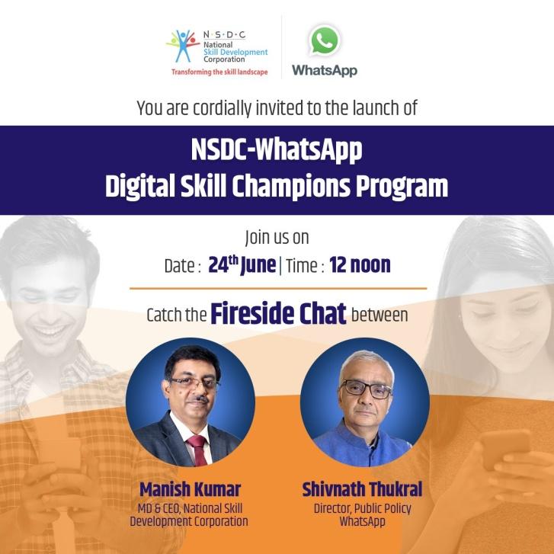

- The programme aims to train Indian youth on digital skills to make them employment ready.
- It will be implemented across the broad areas of collaboration - WhatsApp Digital Skills Academy, Pradhan Mantri Kaushal Kendra (PMKK) and WhatsApp Business App Training sessions.
- Through this programme, school and university students would be trained digital and online skills leading to the awarding of ‘Digital Skill Champions’ certification by WhatsApp and NSDC
- As part of WhatsApp Digital Skills Academy, youth from tier III and IV cities will be trained on aspects of digital safety and online privacy.
- The initiative will be launched with a pilot across 50 campuses in five states - Rajasthan, Madhya Pradesh, Andhra Pradesh, Tamil Nadu and Karnataka.
- The programme will be imparted through WhatsApp's project implementation partner, InfiSpark.

- The Maharashtra National Law University (MNLU-N) at Nagpur – currently trains India’s first batch of law graduates who are eligible to become Judges
- The University trains 40 students, who can become Judges directly after completing their five-year BA LLB (honours) degree in ‘adjudication and justicing’.
- However, the graduates have to clear the examinations conducted by the public service commissions of respective states to be recruited as judges.
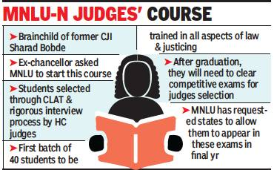

- The course was the brainchild of former Chief Justice of India Sharad Bobde, who is also the first MNLU chancellor
- Bobde had proposed a National Judicial Academy (NJA) on the lines of National Defence Academy (NDA) to train law students in the art of judging.

- One-fourth of air pollution-linked deaths in India - is attributed to the residential emissions, as per a recent study
- The first ever global source apportionment study has analysed the number of deaths which are contributed by the exposure to air pollution from specific sources in both 2017 and 2019
- It is also the first to study the global impacts of specific fuels like solid biomass, coal, oil and natural gas.
- The residential indoor air pollution is caused by the solid biofuel combustion due to emission from cooking, heating etc.,
- The process emits deadly ambient fine particulate matter PM2.5
- The study identified a total of 15 polluting sources for Indian environment
- Out of these, the residential sector made up 25.7%, industry 14.8%, energy 12.5%, agriculture 9.4%, waste 4.2% and other combustion 3.1%
- The total attributable deaths due to PM2.5 in the country are estimated at 866,566 and 953,857 in 2017 and 2019, respectively.
- Complete elimination of coal, oil and natural gas combustion in China and India could reduce the global PM2.5 disease burden by nearly 20%, says the study
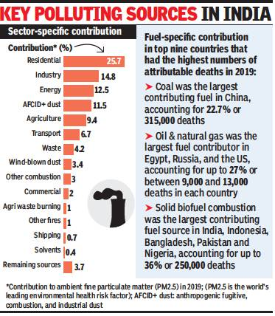

- Globally, 1.05 million deaths were caused in 2017 due to the fossil-fuel combustion, with coal contributing to over half.
- China and India with 58% of total global ambient PM2.5 mortality burden together accounted for the largest numbers of attributable deaths.
- The analysis has been done based on a satellite-derived PM2.5 exposure estimates, and national baseline burden estimates updated from the Global Burden of Disease (GBD) Study 2019.
- In India, areas surrounding Beijing and Singrauli (Madhya Pradesh) have relatively larger contributions of PM2.5 from the energy and industry sectors.

- The Intergovernmental Oceanographic Commission (IOC), an UN body – has recently endorsed a multinational project called ‘Committee on Earth Observation Satellites Coastal Observations, Applications, Services, and Tools (CEOS COAST)’
- The project is co-led by ISRO (Indian Space Research Organisation) and NOAA (National Oceanic and Atmospheric Administration) from the United States
- It seeks to improve the accuracy of coastal data based on satellite and land-based observations to meet several of the 17 UN-designated sustainable development goals for the UN’s Ocean Decade (2021-2030) initiative

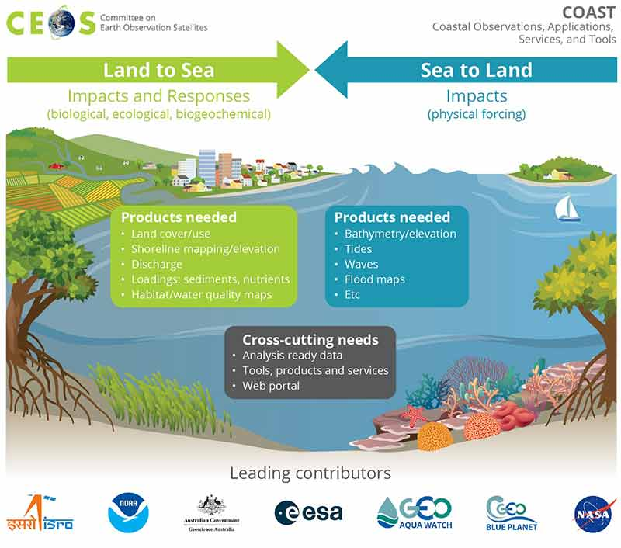

- The themes of these projects include disaster risk reduction and coastal resilience among continental shorelines and small island nations.
- The CEOS COAST aims to integrate governments, industry, academics, NGOs, and other stakeholders to study oceans and develop conservation solutions
- The Committee on Earth Observation Satellites (CEOS) formed the COAST (Coastal Observations, Applications, Services and Tools) team in 2019
- The transition of COAST into CEOS-COAST ad-hoc team was approved in October 2020
- COAST’s Phase 2 implementation commenced in late 2020 and pilot project efforts will continue till 2022 end
- The National Oceanic and Atmospheric Administration (NOAA) is a science-based federal agency within the US department of commerce
INTERNATIONAL
- Pakistan – has been retained in the grey or Increased Monitoring List of the global terror watchdog, Financial Action Task Force (FATF)
- The decision was announced on June 25 at the end of the multilateral watchdog’s five-day virtual plenary meeting under the German presidency
- The Paris-based body admitted that Pakistan had now largely addressed 26 of the 27 items in its 2018 action plan to combat terror-financing.
- The one remaining unaddressed item relates to failing of adequately investigating and prosecuting senior leaders and commanders of UN-designated terror groups.
- So far, Pakistani authorities have only prosecuted senior leaders of Lashkar-e-Taiba (LeT) and Jamaat-ud-Dawah (JuD), including LeT founder Hafiz Saeed and several of his senior aides
- The Lashkar e Toiba (LeT) is the group that carried out the Mumbai terrorist attack in 2008 while the JeM carried out the 2019 Pulwama attack in which 40 Indian paramilitary personnel were killed.
- The next meeting of the FATF is expected in October this year.
- Pakistan was placed in the list of nations under increased monitoring or the grey list in June 2018.
INDIA AND NEIGHBOURS
- Bhutan’s ‘Tax Inspectors Without Borders’ (TIWB) programme – has been launched in partnership with India on June 23, 2021
- The TIWB is a joint initiative of the United Nations Development Programme (UNDP) and the Organisation for Economic Cooperation and Development (OECD)
- India was chosen as the Partner Jurisdiction and will provide the tax expert guidance for this programme.
- This programme is expected to be implemented over a period of two years duration
- During this period, India will support Bhutan in strengthening its tax administration by transferring technical knowledge and skills to its tax auditors, and through sharing of best audit practices.
- The focus of the programme will be in the area of International Taxation and Transfer Pricing.
SCIENCE, TECHNOLOGY & ENVIRONMENT
- Isro and the department of space (DoS) – released the new draft National Space Transportation Policy on June 25
- As per the policy, private companies are allowed to establish and operate rocket launch sites within and outside the country, subject to prior authorisation from the government.
- Similarly, any rocket launch (orbital or sub-orbital) from Indian or overseas territory can be carried out only with authorisation from Indian National Space Promotion & Authorization Center (IN-SPACe)
- The nodal agency, IN-SPACe, shall authorise the launch by the Indian Entity after verifying the clearances accorded by the Ministry of External Affairs or any other Ministry, if applicable
- IN-SPACe is an independent body constituted by the Government of India, under the Department of Space (DOS).
- Further, the policy seeks to encourage partnerships and collaborations with international space agencies for the joint development of technologies for future space transportation systems.
- The Draft National Space Transportation Policy-2020 is comprehensive policy of the Government covering all aspects of rocket launching, launchpads, reentry of a space object and others
- It has to be recalled that the Chennai-based Agnikul Cosmos is developing a small rocket to launch small satellites into orbit.

- Pune-based Serum Institute of India (SII) - to start phase 2 and phase 3 paediatric trials of Covovax in 920 children next month
- The pharma major will commence the trials with 460 children in each of the age groups between 12 to 17 years and 2 to 11 years
- In this regard, the vaccine manufacturer is to apply for permission from the Drug Controller and General of India (DCGI) soon to conduct the trials
- Covovax is the second Covid-19 vaccine candidate, which is being developed and manufactured at Pune-based SII
- SII is currently supplying and manufacturing the Covishield vaccine in technical collaboration with AstraZeneca and Oxford University.
- In September 2020, American biotechnology firm Novavax announced a manufacturing agreement with SII for its Covid-19 vaccine NVX-CoV2373, which is a recombinant nanoparticle protein-based vaccine
- It was developed by Novavax and has been branded Covovax in India.
- It will be the fourth Covid-19 vaccine to go through clinical trials in India, this time for children.
- SII expects to launch Covovax for adults in India by September and for children by the end of this year.
- The children undergoing advanced trials would be followed up for six months after inoculating with two doses of Covovax, given 21 days apart.
- According to the trial design, enrolment of children in the 12 to 17 age group would be done first, followed by younger ones (two to 11 years)
- SII will submit the interim trial findings on safety and immunogenicity after three months of the advanced clinical trial for licensure.
- The SII can apply for a vaccine license even before its trial in the country concludes on the basis of the global data of the trial, according to the latest guidelines of DCGI

DEFENCE
- India’s first ever indigenous aircraft carrier (IAC) - will become fully operational by mid-2023 at the earliest

- The 40,000-tonne carrier, to be named ‘INS Vikrant’, will operate with supersonic fighter jets and multi-role helicopters from its deck
- This was announced by defence minister Rajnath Singh on June 25, 2021
- The Minister was reviewing the ongoing construction of the IAC at Cochin Shipyard at a budget of around ₹23,000 crore
- The commissioning of IAC, the most complex warship ever to be built in India with “about 75% indigenous content”, will take place next year.
- The sea trials of the IAC, which was first sanctioned by the government way back in January 2003, will also start in another couple of months.
- The flight trials of MiG-29K fighters, Kamov-31 airborne early warning helicopters, MH-60R multi-role helicopters and the indigenously manufactured ALHs (advanced light helicopters) will begin from its deck after its commissioning in mid-2022.
- The motto of the IAC is Jayema Sam Yudhi Sprdhah, which is taken from Rigveda 1.8.3

- Indian Navy’s hydrographic survey ship, INS Sarvekshak – has been sent to Colombo for assisting in the seabed survey off Sri Lanka’s coast

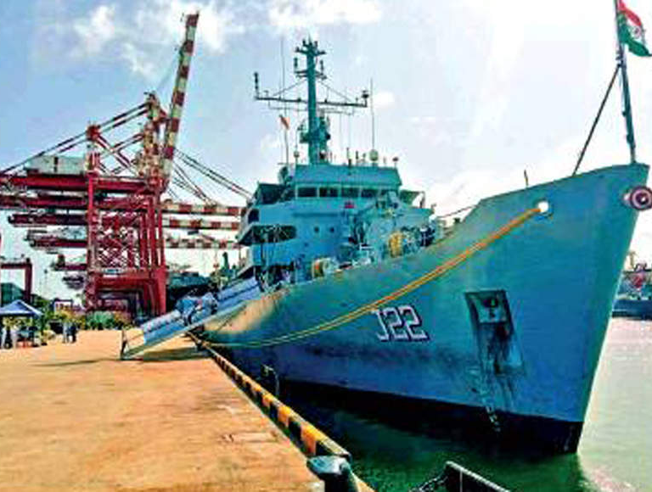

- Cargo vessel, MV X-Press Pearl sank off the coast a month before, leading to the release of hazardous chemicals and plastic pellets into the ocean
- The Indian Navy’s ship will help assessing the condition of the underwater seabed around the site where the vessel began sinking
- The accident site is around 250km from the Indian waters in Gulf of Mannar.
- INS Sarvekshak is a specialised survey ship fitted with state-of-the-art survey equipment like deep sea multi-beam echo sounder, side scan sonars and a fully automated digital surveying and processing system.
- The vessel was carrying 1486 containers containing chemical cargo including nitric acid, methanol, methyl acetate, sodium hydroxide and polystyrene beads.
- The ship caught fire when it was in anchorage on May 20 and later sank off the coast six days later
ECONOMY
- On June 24, Microsoft - became only the second US company after Apple to reach $2 trillion valuation
- The company’s value was elevated due to its dominance in new areas such as cloud computing, machine learning and enterprise software
- Microsoft’s resurgence to glory has largely been credited to its Chief Executive Officer Satya Nadella
- Microsoft’s valuation was less than $400 billion when Nadella became CEO in 2014
- Satya Nadella was appointed chairman of the company -- only the second in its history after Bill Gates — last week.
- The Seattle-based tech giant joined the elite club, in which the third and only other member is Saudi Aramco
- In December 2019, Saudi Aramco almost touched that threshold and currently boasts a market value of $1.9 trillion.
- Amazon has a market cap of $1.8 trillion while Google’s parent company Alphabet has a valuation of $1.6 trillion.
- Microsoft was founded by Bill Gates and Paul Allen in 1975
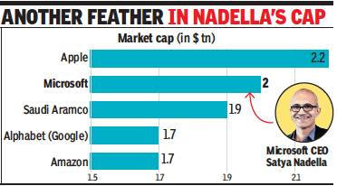

- Microsoft took 33 years to reach its first $1 trillion in 2019, while reaching the next trillion has taken only two years.
- The company has gained 20% this year alone, outperforming Apple and Amazon
SPORTS
- Portugese soccer superstar Cristiano Ronaldo – equals the record for most number of international goals in men’s football

- The 36-year old Ronaldo scored his 109th goal for Portugal in the Euro 2020 game against France on June 23 to equal former Iran striker and Asian football legend, Ali Daei's all-time international record.
- Ronaldo, the leading scorer in European Championship history, matched the record in his 178th international appearance.
- The Juventus striker has now scored 14 Euro goals across five editions of Euro, five more than French legend Michel Platini, who scored all nine goals in one edition when he led France to glory in 1984.
- Ronaldo is the first player to appear at five editions of the European Championships tournament
- He made his international debut at the age of 18 in 2003 against Kazakhstan, playing as a winger
- Ronaldo netted his first international goal in a 2-1 loss to Greece in the opening game of Euro 2004 in Portugal
- Daei, nicknamed the 'Shariar' (King in Persian), scored a remarkable 109 goals in 149 appearances for Iran between 1993 and 2006

