EVERYDAY CURRENT AFFAIRS – DEC 18, 2019

TAMIL NADU
- The Tamil Nadu government - has decided to bifurcate Anna University and create two new institutions, named Anna Institute of Eminence and Anna University.
- The Government has also formed a committee of five ministers to consider the issues that may come up from the Centre’s decision to confer Institute of Eminence (IoE) status on the university.

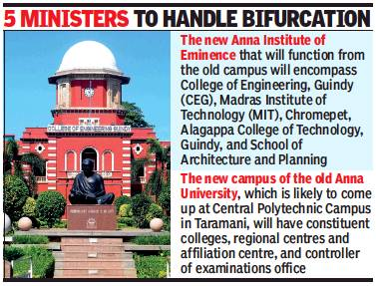
- After getting the IoE tag, the state’s premier technical university cannot affiliate engineering colleges, and hence the government is creating a separate university for the purpose.
- The proposed Anna Institute of Eminence will have College of Engineering, Guindy (CEG), Madras Institute of Technology (MIT), Chromepet, Alagappa College of Technology, Guindy, and School of Architecture and Planning
- Anna University will have all the constituent colleges, regional centres and the affiliation centre, the controller of examinations office and a new campus along with it.
- The new campus is likely to come up at the Central Polytechnic in Taramani.
- The committee will comprise of Higher education minister K P Anbalagan, school education minister K A Sengottaiyan, electricity minister P Thangamani, fisheries minister D Jayakumar and law minister C Ve Shanmugam
- The ministers will be assisted by the higher education secretary, finance (expenditure) secretary and law secretary.
- Anna University is one of the 10 public institutions shortlisted for IoE status
- An institution with IoE status is eligible for a grant of up to Rs1,000 crore in 5 years from the Centre
- Previously, Anna University was split into five regional universities in Chennai, Madurai, Coimbatore, Tirunelveli and Trichy from 2007 and the parent university was converted as non-affiliating university.
- The regional universities were then clubbed together as single affiliating university in 2012.
SUPREME COURT VERDICT
- The Supreme Court - has formed a two-judge committee to ensure expeditious disposal of rape cases across India.
- The committee was set up by Chief Justice SA Bobde.
- It comprises of two members, which includes Justices R Subhash Reddy and MR Shah.

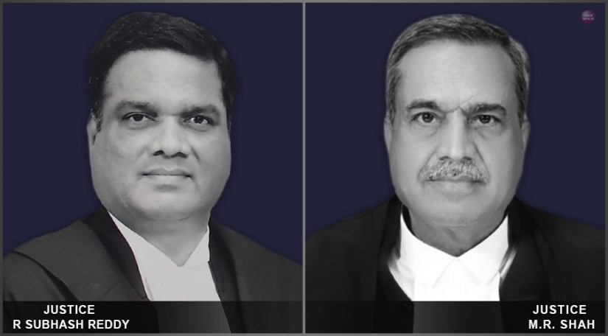

- The committee would be monitoring the concerned cases through the respective High Courts.
- On December 17, a three-judge bench of the Supreme Court, headed by CJI SA Bobde and comprising Justices Ashok Bhushan and R. Banumathi had begun hearing the Nirbhaya rape case
- However, the CJI recused himself from the hearing citing personal reasons

INTERNATIONAL
- Pakistan’s former military ruler, General Pervez Musharraf - was convicted and sentenced to death, in absentia, by a special court on December 17

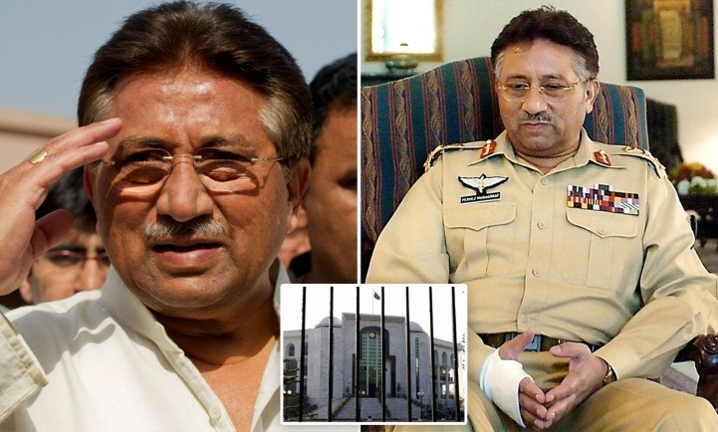

- The court has pronounced the verdict in a high treason case over his imposition of emergency rule in the country in November 2007, as per Article 6 of Pakistan’s constitution.
- The 2-1verdict was announced by a special court bench headed by Peshawar high court Chief Justice Waqar Ahmad Seth and comprising Justice Nazar Akbarand Justice ShahidKarim.
- Justice Akbar had dissented from the verdict
- Pervez Musharraf was the 10th President of Pakistan
- He served the country from 2001 until his resignation in 2008.
- Musharraf remained as the Chairman of the Joint Chiefs till 2001 and Chief of the Army Staff till his retirement in 2007
- The 76 year old Gen Musharraf is the first military ruler of Pakistan to be tried and convicted for overruling the constitutional article.
- Three other Pakistan generals — Ayub Khan, Yahya Khan and Ziaul-Haq — had also overruled the constitution and stayed in power, but none of them faced trial
- According to Article 6, “any person who abrogates or subverts or suspends or holds in abeyance, or attempts to abrogate... the constitution... shall be guilty of high treason”.
- The punishment for high treason, according to the High Treason (Punishment) Act, 1973, is death or imprisonment for one’s lifetime.
- Musharraf’s legal team can now appeal against the verdict in the Supreme Court within 30 days.
- Musharraf had ruled the country for 9 years after overthrowing the elected government of former PM Nawaz Sharif in a military coup in 1999.
- Even though Musharraf had first imposed a state of emergency in the country in 1999, he was currently tried for high treason for his actions of November 2007.
- On November 3, 2007 he had imposed emergency for the second time, suspending the constitution and detaining politicians and judges of the superior courts.
- By mid-December, he announced the end of emergency after introducing legislation granting protection to some of the actions he had taken during that time.
- Musharraf, 76, was born in Neharwali Haveli in Old Delhi in 1943.
- After the Partition, his parents moved to Karachi where millions of refugees migrating from India had settled.
- Musharraf was commissioned in Pakistan’s army in 1964 and involved in the country’s 1965 and 1971 wars against India.
- Despite being third in seniority, he was appointed to lead the army by then PM Nawaz Sharif in 1998.
- Both Musharraf and Sharif had presided over Pakistan’s nuclear tests in May 1998, conducted following similar tests by India days earlier
- The army’s involvement in the Kargil War in May 1999 caused a major rift between Musharaff and Sharif
- He declared himself “Chief executive” of the country in 1999 and placed Shariff under House Arrest
- In May 2002, Musharaff organised a general election and brought a party of his own loyalists, PML-Q, to power.
- The same year he got himself elected from parliament as the country’s President
- In 2008, he relinquished his President post to avoid impeachment and left the country into a self-imposed exile
- In 2013, he returned to Pakistan to contest general elections but was barred by the courts and the trial had been pending since.
- He moved to Dubai for the treatment of Amyloidosis, which is a rare condition, in 2016.

INDIA AND NEIGHBOURS
- The train service between Lahore and Wagah - resumed operations after 22 years on December 15, 2019.
- There will be three shuttle trips daily between both the stations, with the train taking about an hour to reach the destination
- The Lahore-Wagah train was in service till 1997, after which it was suspended due to certain operational and security reasons.
- Wagah station, which is the last station in Pakistan on the Lahore–Wagah railway line, serves as a sub-urban border station, before crossing into India.

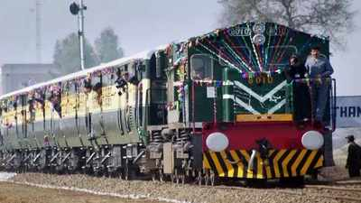
- The station is used for immigration and custom clearance of passengers who travel between India and Pakistan through the Samjhauta Express.
- The train service is highly beneficial to hundreds of travellers who wish to watch the flag hoisting and lowering ceremony at the Wagah border

CONFERENCES & SUMMITS
- The first ever Global Refugee Forum - is currently in progress in Geneva, Switzerland from 17-18 December 2019
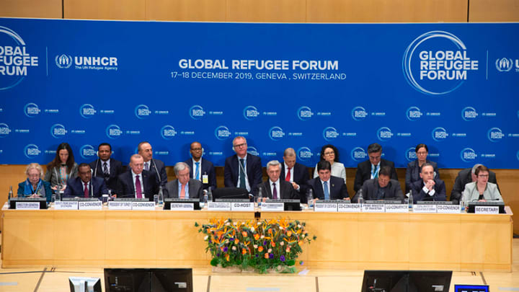
- Government of Switzerland is jointly hosting the forum along with United Nations Refugee Agency (UNHCR)
- The forum, with the participation of ministers of various countries, will work together to address the current global refugee situation.
- It also hopes to arrive at the ‘missing middle’- the states that could either contribute more or host more refugees.
- The forum will ensure the practical implementation of the 2018 Global Compact on Refugees (GCR)
- GCR is a platform that aims to integrate international community as a whole for increased cooperation and solidarity with refugees as well as affected host countries

PERSONALITIES
- M Vanitha, who was the project director for Chandrayaan-2, has been replaced by P Veeramuthuvel from Isro headquarters in the Chandrayaan-3 team

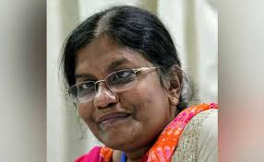

- However, Ritu Karidhal, whose team was responsible for the mission, continues to be mission director for Chandrayaan-3.
- Vanitha’s team was responsible for all systems on Chandrayaan-2, whose lander failed to soft-land on the Moon on September 7

DEFENCE
- The DRDO (Defence Research and Development Organization) – successfully test fired the supersonic Cruise missile Brahmos from Odisha’s Chandipur Integrated Test Range on December 17, 2019.

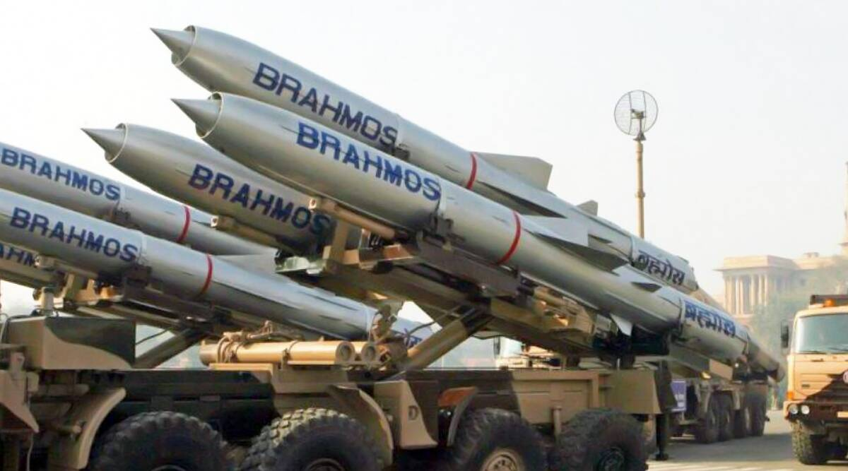

- The medium range missile can be launched from warships, submarines, land or fighter jets and is known for its anti-ship capabilities and land-attack capabilities.
- The missile is operational with Indian Navy, Army and Air Force.
- Brahmos is a joint venture between DRDO of India and NPOM of Russia
- India extended the range of BRAHMOS missile to 600 km, after entering into Missile Technology Control Regime (MTCR)
- Brahmos is also one of the fastest cruise missiles that can operate at the speed of 2.8 Mach, which is three times the speed of sound.
- Earlier, in May 2019, DRDO test fired Brahmos by launching it in the air from Su-30MKI aircraft.
- Later the Eastern command unit test-fired the missile from Car Nicobar islands.
- In September 2019, DRDO conducted the Brahmos full range test of 290 km in Chandipur, Odisha
- On December 16, 2019, Phillipines confirmed to sign contract with India for medium range Brahmos Cruise Missiles in 2020 during the visit of PM Modi to Phillipines

- The 14th edition of 'Surya Kiran' annual military exercise between India and Nepal - concluded on December 16, 2019 at Salijhandi of Rupendehi district of Nepal.
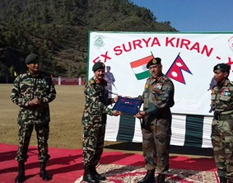
- About 300 soldiers from the armies of both the countries took part in this year's 'Surya Kiran' exercise.
- During the exercise, the armies of both countries undergone training in retaliatory operations in jungle warfare and counter-terrorism operations in mountainous terrain, humanitarian assistance and disaster relief, medical and environmental conservation including aviation aspects.
- Exercise SURYA KIRAN - XIV is an annual event which is conducted alternatively in Nepal and India.
SPORTS
- India opener Smriti Mandhana- was named in both the International Cricket Council’s ODI and T20 teams of the year

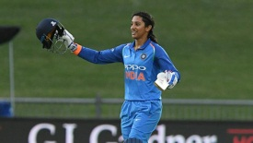
- Australia’s Ellyse Perry, who scored 441 runs at an average of 73.50 and took 21 wickets at 13.52, was named as the ODI cricketer of the year
- Apart from Mandhana, Jhulan Goswami, Poonam Yadav and Shikha Pandey were named in the ODI team of the year and all-rounder Deepti Sharma was named in the T20 side.
- Mandhana has played 51 ODIs and 66 T20Is for India, scoring a combined tally of 3476 runs in T20Is and ODIs.
- Australia’s Alyssa Healy was chosen as the T20 cricketer of the year following her record-breaking 148 against Sri Lanka earlier this year.
- Australian Meg Lanning was chosen as captain of both the ODI and T20 side.

RANKINGS
- India - has slipped to 112th position, as per the Gender Gap Index-2019 released recently by World Economic Forum (WEF)
- Last year, in 2018, India was on the 108th position in the Index in terms of gender equality.
- India is ranked in the bottom five on health and economic fronts.
- As per the report, workplace inequality will not be erased until the year 2276 according to the prevailing scenario.
- The first WEF Gender Gap Index was published in 2006, in which India was ranked at 98th position.
- In the 2019 index, India was placed at 150th place on health and survival, 112th on educational attainment and 149th in economic participation
- Iceland (1st) is ranked as the most appropriate country for women representation followed by Norway (2nd) Finland (3rd) and Sweden (4th).
- These countries are followed by Nicaragua, New Zealand, Ireland, Spain, Rwanda, and Germany to complete Top 10.
- Apart from that, other prominent Asian countries in the list includes China at 106th, Bangladesh - 50th, Nepal - 101st, Indonesia - 85th and Sri Lanka – 102nd.

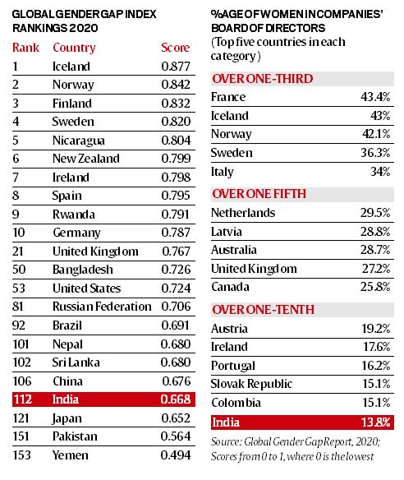
- World Economic Forum is a non-profit organization based in Switzerland, with its headquarters in Geneva.
- It was established in January, 1971 by Professor Klaus M. Schwab, working at the University of Geneva as Business Professor, in the name of European Management Forum.
- It was renamed as World Economic Forum in the year 1987
- Since 1949, WEF organizes an annual meeting every year in the month of January called Davos.

