EVERYDAY CURRENT AFFAIRS – DEC 29, 2019

TAMIL NADU
- Spanish firm, Urbaser – commences the garbage collection and disposal in 7 zones of the Greater Chennai Corporation
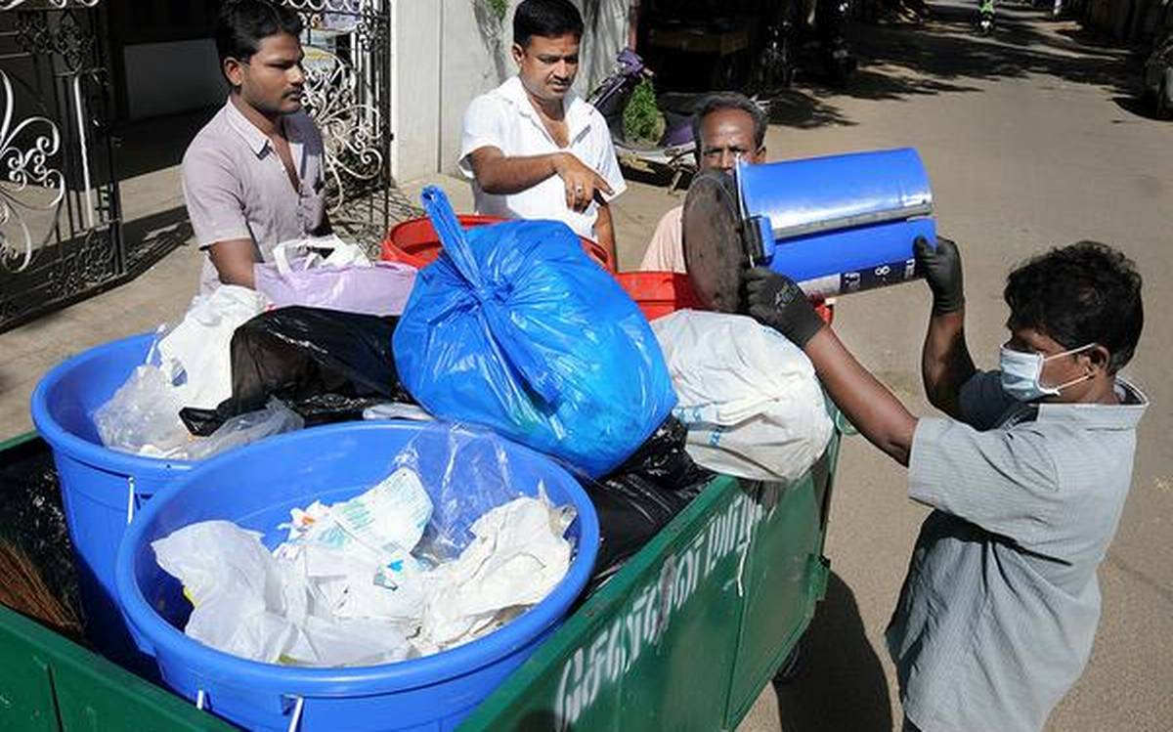
- The project will cover about 9 lakh households in these zones
- It is estimated to cost around ₹447 crore to the exchequer.
- The work orders for the project were recently issued to Urbaser, which specialises in environmental management, and Sumeeth Facilities Private Limited
- The firms will be involved in conservancy operations for a period of 8 years
- The conservancy operations were commenced in 7 zones, including Alandur, Perungudi and Sholinganallur in south Chennai.
- The conservancy operations in these zones will be monitored by a third-party consultant.
- The segregated waste will be sent to micro-composting centres, and efforts are being taken by the civic body to reduce the volume of garbage reaching dumpyards.
- Unlike the earlier model in which contractors were paid according to the tonnage of waste collected, the civic body will henceforth make payment based on 34 key performance indicators for conservancy operations.
- The performance indicators include 100% source segregation compliance in one year, complaint redressal within 12 hours and use of battery-operated vehicles for collection and proper disposal.

STATES
- Hemant Soren, executive president of the Jharkhand Mukthi Morcha - will take the oath of office as the 11th Chief Minister of Jharkhand at the Morabadi ground in Ranchi on December 29

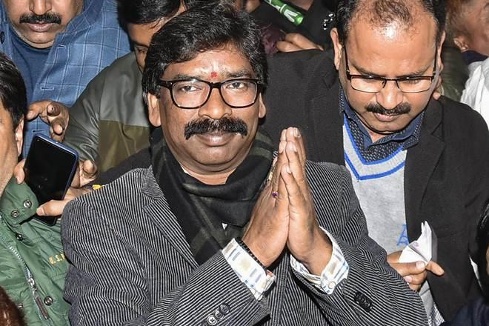
- Jharkhand Governor Droupadi Murmu administered the oath of secrecy and office to Hemant Soren
- This is his second term as the Chief Minister of the state.
- He had earlier served as the 5th Chief Minister of the state from July 2013-December 2014.
- His father Shibu Soren was also a three-time Chief Minister.
- In the 81-member Jharkhand Assembly, JMM has won 30 seats while its alliance partners, Congress and RJD, have won 16 and 1, respectively.
- The Jharkhand Vikash Morcha (Prajatantrik), led by former Jharkhand Chief Minister Babulal Marandi, with three MLAs has also extended unconditional support to Soren-led alliance.
- The BJP with 25 seats will be the principal Opposition party in Jharkhand.
- Earlier, the party’s incumbent CM Raghubar Das himself lost from his bastion constituency- Jamshedpur East.
- Hemant Soren had also served as the Deputy CM of Jharkhand from September 2010 to January 2013.
- He had also been a Member of the Rajya Sabha from June 2009-January 2010.
- Hemant Soren belongs to Santhal ethnic tribal community

- The Gwalior district administration - has made it mandatory for arms licence applicants to donate 10 blankets for cows or serve for 3 days in a gaushala (cow shelter).
- There are 2 gaushalas within Gwalior city limits, housing 12,000 cows totally.
- There are around 18,000 gun licence holders in Gwalior, and many apply every year.
- Earlier, the Corporation had mandated that arms licence seekers had to plant saplings as part of the application process.

NATIONAL
- Tirumala Tirupati Devasthanams (TTD) - has decided to construct Lord Balaji’s replica temples in Varanasi, Union territory of Jammu and Mumbai.
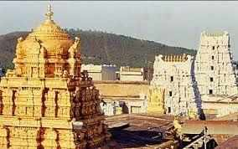
- The board had given administrative sanction of ₹30 crore for the construction of the Sri Venkateswara temple and information centre at Bandra in Mumbai.
- The TTD administers the temple of Lord Venkateswara at Tirumala
- It has to be recalled that Varanasi is the Prime Minister Narendra Modi’s Lok Sabha constituency

- The second Privately operated IRCTC’s premium Tejas train - will be launched on January 17
- It will ply between Ahmedabad and Mumbai and have its first commercial run on January 19
- The first Tejas Express currently runs on the Delhi-Lucknow route
- The Railway had earlier announced that it will compensate the passengers if these private trains get delayed
- All passengers traveling on the train will be provided with Rail Travel Insurance of up to ₹25 lakhs, free of cost by the IRCTC, including an exclusive coverage of ₹1 lakh against robbery during the travel period of passengers
- There will be no tatkal or premium tatkal quota in the train

- The central government - has made Aadhaar mandatory for the Pradhan Mantri Vaya Vandana Yojana.
- The scheme basically caters to the pension requirement of senior citizens.
- Now, it has been announced that its beneficiaries will have to provide Aadhaar as proof of identity.
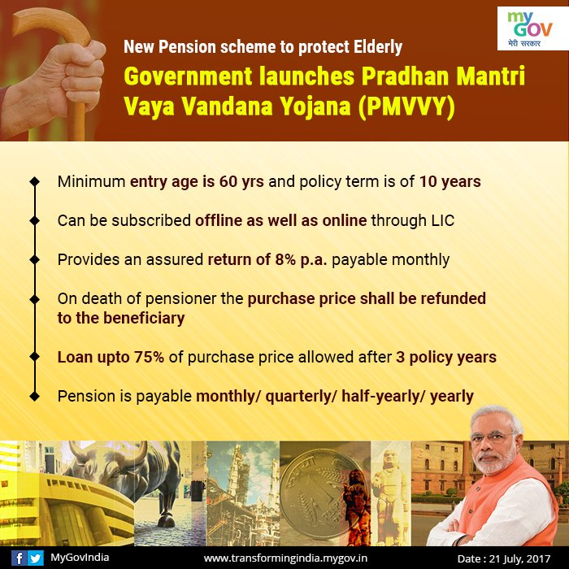
- This pension scheme is for the senior citizens of 60 years or above.
- An annual 8% return is provided for 10 years under this scheme.

INTERNATIONAL
- Pakistan - has rolled out the first batch of its indigenous dual-seat fighter jets at the Aircraft Manufacturing Factory in Kamra near Islamabad on December 27
- The fighter jets were manufactured in a record time of five months in collaboration with its ally, China.
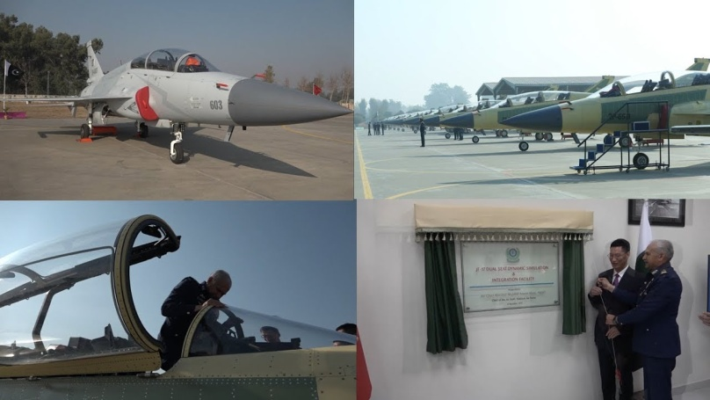
- The first batch of eight dual-seat JF-17 aircraft was manufactured by the Pakistan Aeronautical Complex (PAC) in association with the China National Aero-Technology Import & Export Corporation (CATIC).
COMMITTES
- The statistics ministry - has constituted a 28-member Standing Committee On Statistics (SCES) to improve quality of data in the country.
- It will be chaired by former chief statistician, Pronab Sen
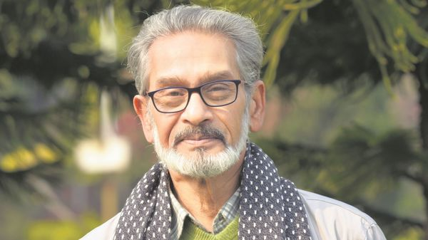
- The first meeting of the SCES is scheduled on January 6, 2020

PERSONALITIES
- Nobel laureate Malala Yousafzai - was declared as the ‘Most Famous Teenager in the world’ by the United Nations in its 'Decade in review' report released recently

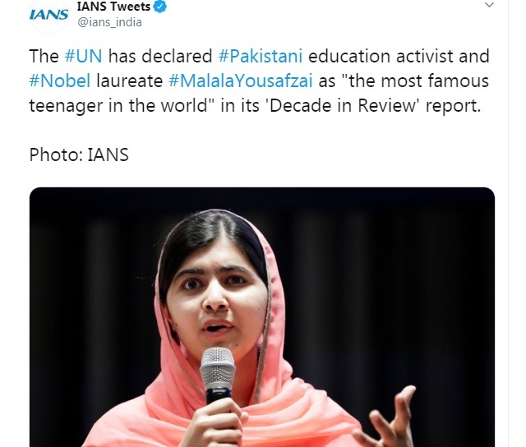

- Ever since her young age, activist Malala was vocal in her speeches advocating education for girls, highlighting the atrocities perpetrated by the Taliban
- She gained the global fame and attention after featuring in a documentary by a prominent international media house
- The documentary tracked her life in the volatile Swat Valley, which lies in the northwest of Pakistan
- She was shot in the head by a Taliban gunman while taking a bus from school in October 2012, from which she survived and recovered
- The shocking attack was widely condemned and a special tribute was paid to Malala at the UNESCO headquarters in Paris on Human Rights Day in the same year.
- Malala was conferred with the Nobel Peace Prize for the year 2014 along with Indian social reformer Kailash Satyarthi, becoming the youngest recipient of the coveted award
- She was also appointed as the UN Messenger of Peace in 2017 with a special focus on girls’ education.

- Vijay Kumar, an Indian Police Service (IPS) officer of the 1997 batch - was appointed the Inspector-General of Police (IGP), Kashmir
- He has received three gallantry medals from the Central government for his exceptional service in anti-terror operations.
- He replaces S.P. Pani, who has been transferred and posted as IGP, Armed Wing, Kashmir
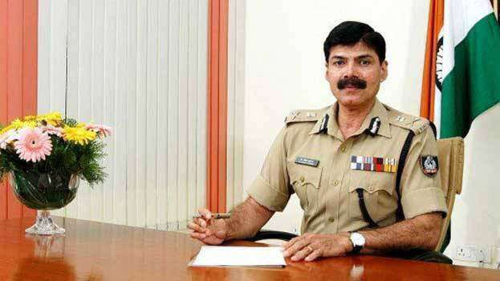
- Pani, a 2000- batch IPS officer, joined as the IGP in February 2018 at the age of 41, becoming the youngest ever to hold the post.

ECONOMY
- The Government - announces that there will be no additional merchant discount rate (MDR) charges for transactions using Ru-Pay debit card or UPI QR codes from January 1, 2020.
- In addition, all businesses with annual turnover of ₹50 crore or more will have to mandatorily offer these two (RuPay debit card and UPI) digital mode of payment options to their customers
- Finance minister Nirmala Sitharaman announced these measures after holding a review meeting of the banking sector with CMDs of public sector banks in New Delhi on December 28
- The government and RBI had earlier ordered a waiver of MDR charges on transactions up to ₹2,000 using various payment tools, which has now been expanded to cover all transactions
- In her maiden budget in July, the Finance Minister had proposed that businesses should offer low cost digital modes of payment such as BHIM UPI, UPI QR Code, Aadhaar Pay, Debit Cards, NEFT, RTGS, etc. to their customers

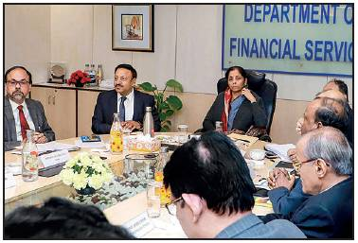
- She also announced that no charge or MDR will be imposed on customers to promote digital payment.
- The Government has earlier amended 2 laws — the Income Tax Act and the Payments and Settlement Systems Act — in order to implement the budget announcement
- The banks have been instructed to launch campaigns to popularise RuPay debit card and UPI, in order to strengthen the digital payment ecosystem and achieve a cashless economy.
- On the occasion, the Finance Ministry has launched e-Bkraya, a common e-auction platform to aid debt recovery from the various defaulters
- Through the portal, the Government intends to sell 1.73 lakh properties, worth ₹2.3 lakh crore, that have been attached by PSBs over the last three years.
- The Merchant Discount Rate is the percentage of the digital transaction that a merchant pays to banks, which has been transferred on to the customers
SPORTS
- Six-time world champion, M C Mary Kom - sealed her spot for Olympic qualifiers with a 9-1 verdict against Nikhat Zareen (Telangana) in flyweight (51kg) bout at the Indira Gandhi Indoor Stadium in New Delhi
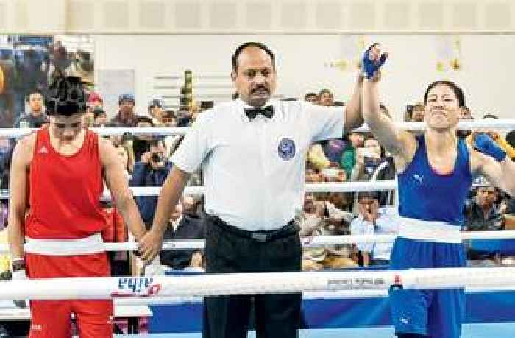
- At the end of 9 minutes and 3 tight rounds, 36-year-old Mary prevailed over 23-year-old Nikhat through a split decision.

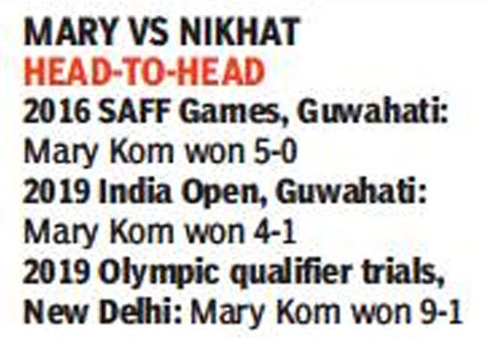
- With the win, Kom had earned the right to represent India in the 51-kg bout on the Olympic qualifiers in Wuhan, China next February.
- During the trials, the Boxing Federation of India (BFI) had put in place a jury comprising 10 members.
- The usual 5 judges were there - along with them were 3 national selectors, the High performance director for Indian women’s boxing Rafael Bergamsco and the Chief women’s coach Md. Ali Qamar.
- Indian squad for Olympics qualifiers:
  - MC Mary Kom (51kg), Sakshi Chaudhary (57kg), Simranjit Kaur (60kg), Lovlina Borgohain (69kg) and Pooja Rani (75kg)

- Punjab and Indian Railways - retains the men and women’s titles in the 70th Senior National Basketball Championship at Ludhiana, Punjab
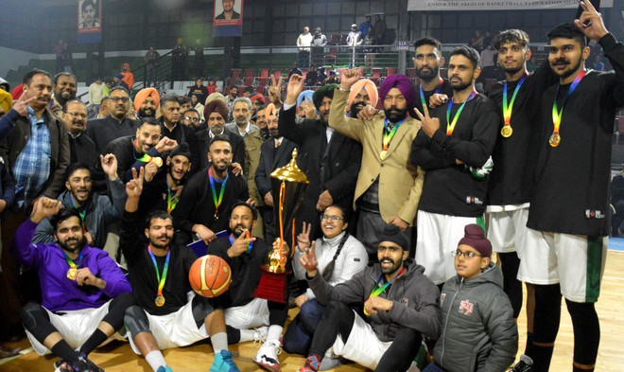
- Both the victorious teams remained unbeaten throughout the tournament, highlighting their superiority in the tournament
- In the men’s event, Punjab defeated Tamil Nadu to win their eighth championship crown
- Indian Railways women outscored Kerala to complete a hat-trick of titles – taking their tally of national titles to 30
- The 30th national crown is the eighth time Railways completed a hat-trick.
- Arshpreet Bhullar of Punjab was adjudged as the Most Valuable player of tournament
CO₂ EMISSIONS EXPORTERS IN ASIA - REPORT
