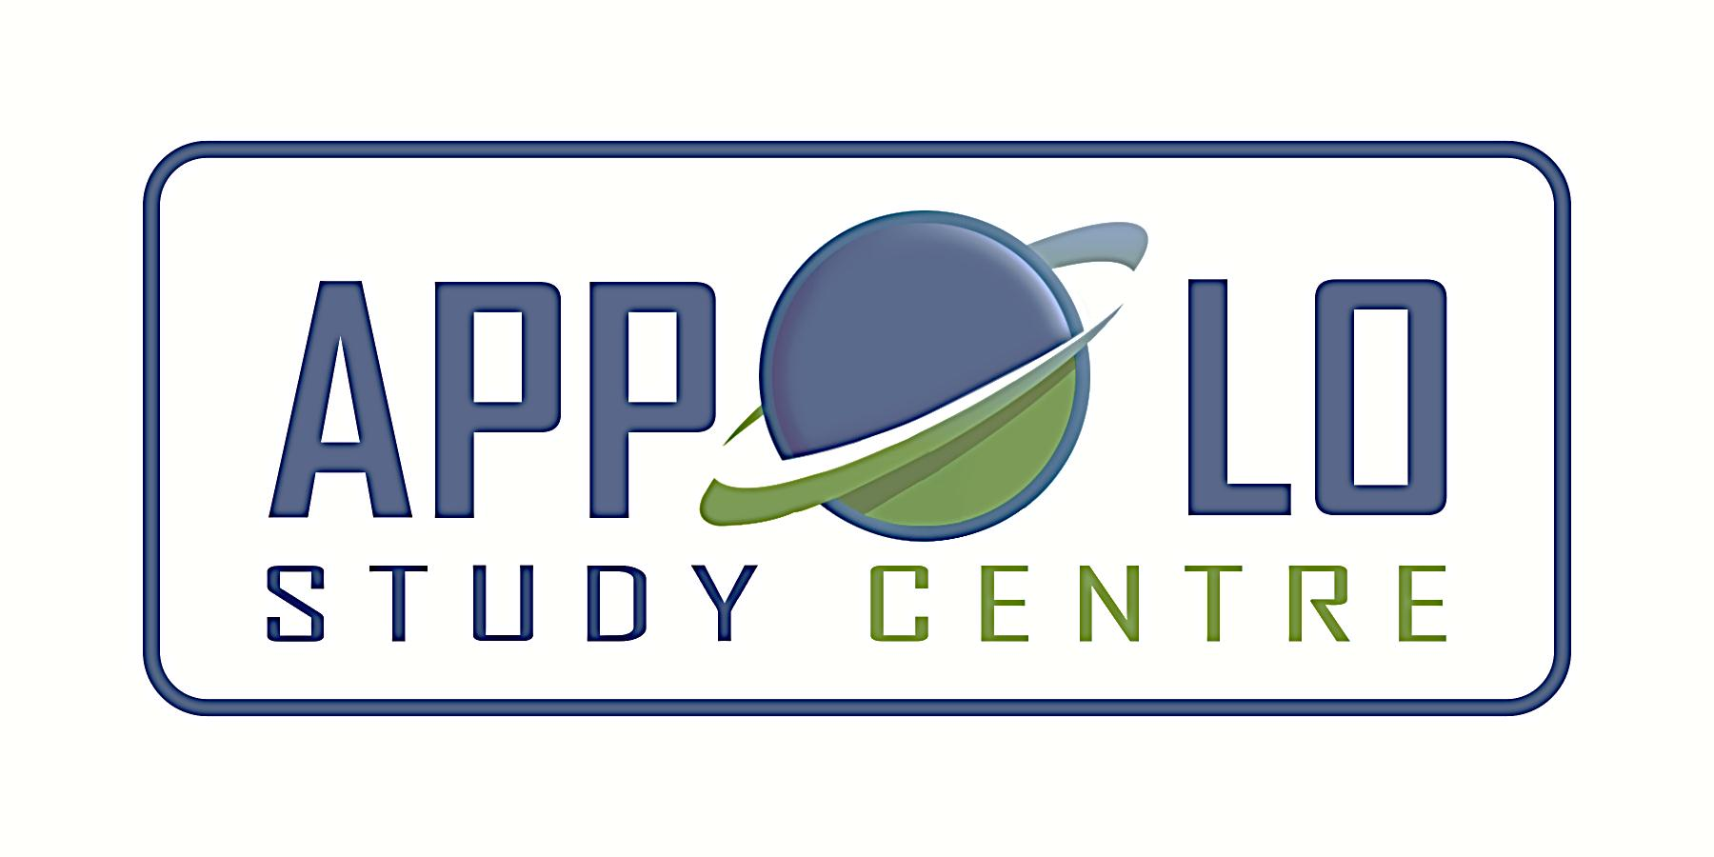
EVERYDAY CURRENT AFFAIRS – DEC 24, 2019

TAMIL NADU
- The Tamil Nadu Government’s Department of Fisheries - signed a tripartite agreement with NABARD on December 23 for the implementation of Fisheries and Aquaculture Development Fund (FIDF) to set up three fishing harbours in the state
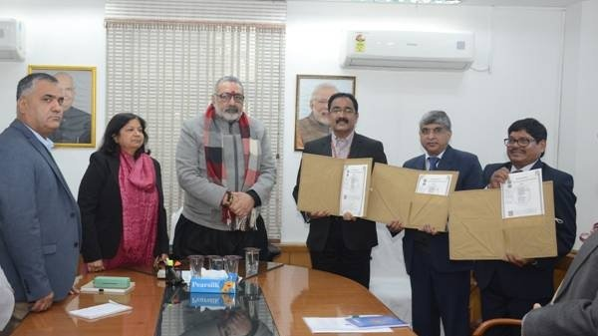
- The Union government’s Department of fisheries is the third party in this agreement.
- Under the agreement, the state will receive initial concessional finance of ₹420 crore from the National Bank for Agriculture and Rural Development (NABARD) for setting up harbours at Tharangampadi in Nagapattinam district, Thiruvottriyur Kuppam in Tiruvallur district and Mudhunagar in Cuddalore.
- Giriraj Singh, Union Minister for Fisheries, Animal Husbandry was present on the occasion
- In future, other coastal states such as Andhra Pradesh are likely to sign similar pacts for concessional finance under the fund.
- A financial allocation of Rs 7522 crores will be set aside to address the infrastructure requirement of fisheries sector in the southern coasts of Tamil Nadu
- Under the agreement, the coastal states are necessitated to pay attention to deep-sea fishing, post-harvesting, cage culture, and export promotion
- In the entire country, Tamil Nadu ranks fourth in total fish production.
- India ranks second in the world fish production, contributing 1% of country’s GDP

- The Tamil Nadu government - is planning to procure 640 electric buses and intends to set up 260 charging points for them
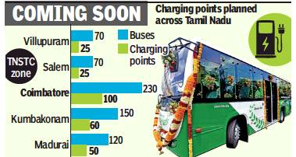
- Pallavan Transport Consultancy Services (PTCS), which functions under the state transport department, has invited bids for direct supply of ebuses under the central government’s FAME II (Faster Adoption and Manufacturing of Electric Vehicles) scheme.
- The Centre will be providing a subsidy in the range of around ₹50 lakh-₹55 lakh for each e-bus, whose costs range between ₹1.5 crore and ₹2 crore.
- The state will have to pay the balance cost based on its annual budget allocation.
- After considering new proposals, the cost involved will be worked out and buses will be procured under the Gross cost contract (GCC) model
- In GCC modal, the private operator will own and maintain the buses and charging stations will be set up at respective depots
- In this model, the buses will not be operated by state transport corporation drivers
- The GCC mode was chosen as it will not put the government at risk in the the scheme that involves huge money apart from providing a chance to learn about the emerging technology from private suppliers
- Accordingly, two different e-bus models are likely to hit TN roads soon.
- The first one will be 9-metres long and have a seating capacity of 32.
- The second one, a 12-metres model, can accommodate up to 40 passengers at a time.
- Both models will allow 20-30 people to travel standing

- The State Government - has relaxed guidelines for Amma two-wheeler subsidy scheme meant for working women in order to cover more applicants.
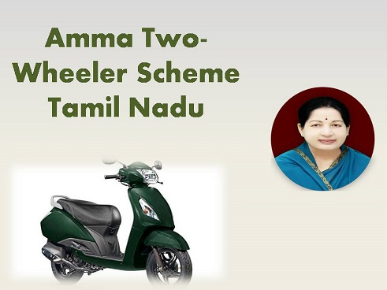

- The state government provides 50% of the vehicle cost or ₹25,000 as subsidy for working women, who wishes to buy a two-wheeler (less than 125cc).
- So far, women residents of the state between 18 and 40 years of age can apply for the subsidy, according to the scheme's original guidelines
- Now, an order issued in November revising the upper age limit to 45.
- Under the original norms, an applicant should have appeared in Class VIII exams to avail benefits under this scheme, and the recent order has removed this minimum educational qualification
- Last year, more than two lakh women, including 30,000 from Chennai, have applied for this scheme for which the state government spends around ₹150 crore every year.

- Chief Minister Edappadi K. Palaniswami - has handed over a cheque for ₹1 crore to Houston University, Texas, for setting up a Tamil Chair.
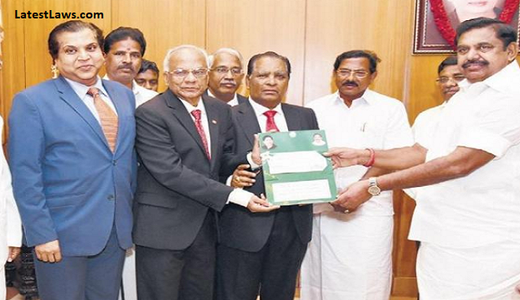

- The Tamil Nadu government made the offer after receiving a request from the Houston Tamil Studies Chair.
- Separately, Deputy Chief Minister O. Panneerselvam donated ₹7 lakh from his personal funds for the same purpose of setting up of the Tamil Chair.
- The cheque was handed over by the CM to Sam Kannappan, founding member and board president, Houston Tamil Studies Chair.

- The draft of the Special Summary Revision of Electoral Rolls, 2020 - was released in all districts by the respective Collectors
- Of a total of 6,00,01,329 voters in the entire state, 50.59% (3,03,49,118) were women, while 49.4% (2,96,46,287) were men.
- There were 5,924 third gender voters.
- Among the major districts, Chennai had a total of 38.88 lakh voters, of which 19.71 lakh were women, 19.15 lakh were men and 989 were others.
- Sholinganallur, with 6,46,073 voters, and Harbour with 1,69,620 voters, were the largest and smallest Assembly constituencies respectively in Tamil Nadu, in terms of the size of the electorate.
- In Chennai, the highest number of electors are available in Velachery constituency (3.03 lakh).
- The Harbour constituency, with 1.69 lakh electors, has the least number of voters.

NATIONAL
- The Jharkhand Mukti Morcha – Congress - Rashtriya Janata Dal alliance - won a comfortable majority of 47 seats in a House of 81 in the Jharkhand assembly elections
- This is the highest-ever tally of seats won individually in the state ever since its formation in 2000.

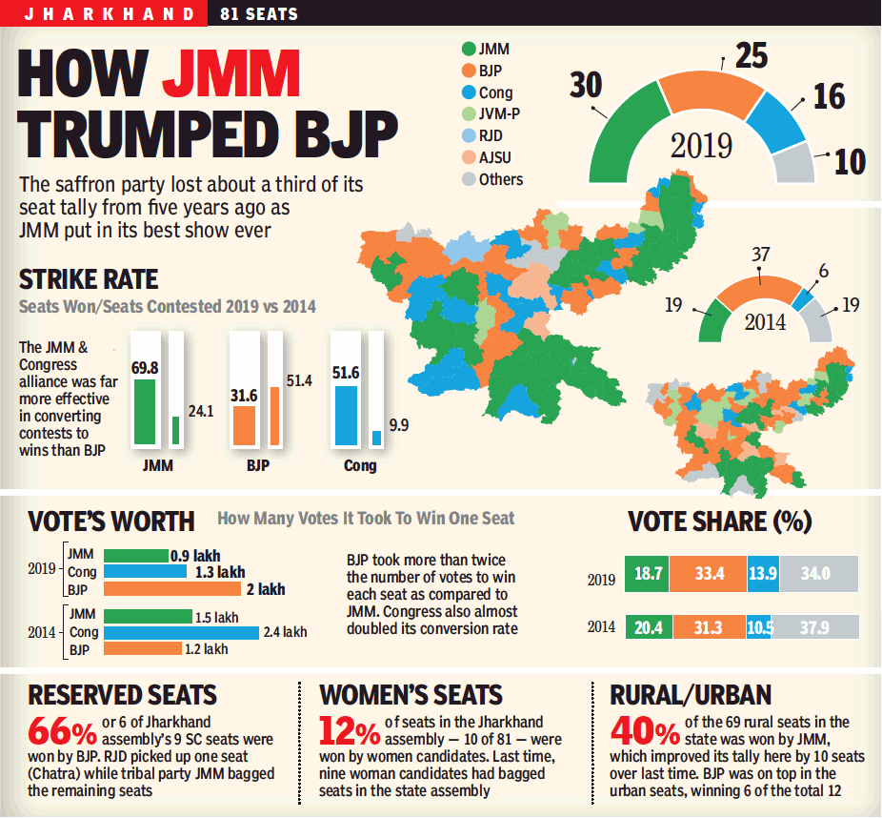
- While JMM had bagged 30 seats, its partners Congress had secured 16 and RJD one seat.
- Hemant Soren of JMM is all set to take over as chief minister, returning to the job which he held for a year before BJP won in 2015
- The oath taking ceremony will take place on December 26
- BJP dropped to 25 seats from 37 it held in 2014, after contesting alone ending its alliance with regional ally, AJSU Party
- The Congress increased its tally to 16 compared to 6 in 2014.
- The incumbent CM Raghubar Das was defeated from his bastion Jamshedpur East by independent Saryu Roy.
- In the LS elections, BJP won 11 and AJSU won a lone seat of Jharkhand’s total 14 seats

- Indian Railways has opened an ‘Oxygen Parlour’ at Nashik railway station in Maharashtra.

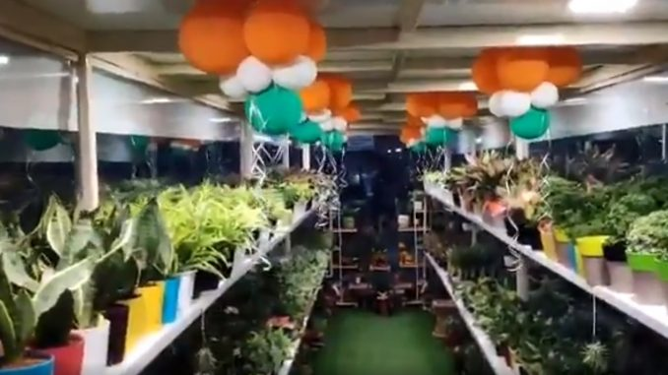
- The initiative seeks to provide an experience of breathing clean air to the commuters and to combat air pollution in the railways stations.
- There are nearly 1500 plants stacked in Oxygen Parlour, so that these plants can directly and effectively bring down the pollution in the air at the railway station
- The parlour has been set up jointly in collaboration with Airo Guard, a one of the leading consultancies in field of plant nurseries based in Nashik.
- The concept of Oxygen Parlour is based on recommendation of the National Aeronautics and Space Administration (NASA)

- A State-of-the-Art DNA Analysis Centre – was inaugurated at Central Forensic Science Laboratory (CFSL), Chandigarh.
- It was unveiled by Minister of State (MoS) for Home Affairs Nityanand Rai
- This new Advanced Forensic DNA Analysis Lab has been established under Nirbhaya Fund scheme.
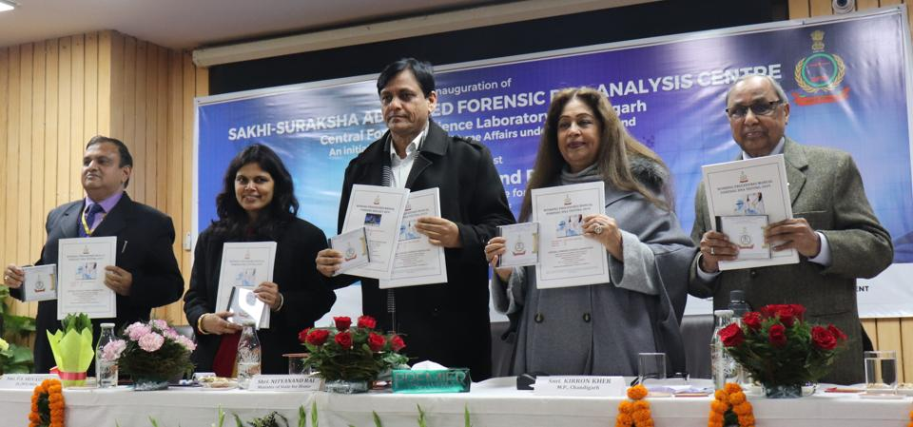
- It has been set up with an allocation of Rs.99.76 crores
- DNA Analysis is one of the foremost tool to ensure efficiency in modern criminal investigation
- The Central Forensic Science Laboratories (CFSLs) are currently functioning at Pune (Maharashtra) Bhopal (Madhya Pradesh), Chandigarh, Guwahati (Assam), Kolkata (West Bengal) and Hyderabad (Telangana).

- A skilling platform called ‘Future Skills’ – was launched by Information Technology firm, Wipro in partnership with IT body NASSCOM (National Association of Software and Services Companies)
- It will focus on new age cutting edge technologies such as Artificial Intelligence (AI), Internet of Things (IoT), Big Data, Cloud Computing and Cybersecurity, which are aimed to reach 10,000 students from over 20 engineering colleges in the entire country
- The initiative is a part of Wipro’s Corporate Social Responsibility (CSR) programme, TalentNext
- The programme aims to improve the quality of engineering education by preparing faculty and academic leaders to train students.

- Google-backed hyperlocal delivery startup, Dunzo and Bengaluru-based drone maker Throttle Aerospace Systems - have been approved by Directorate General of Civil Aviation (DGCA) to test long-range and autonomous drone use.
- The long range drones can significantly improve logistic services in the entire country
- The approvals are a part of the DGCA’s experimental programme, called Beyond visual line of sight (BVLOS) drone operations, which was earlier notified in May 2019.
- The two companies are expected to begin the mandatory 100 hours of experimental drone flights from February 2020 and have identified airspaces outside of Bengaluru

INTERNATIONAL
- The Islamic Republic of Afghanistan - has become the first country to recognize Indian Pharmacopoeia (IP)
- The formal recognistion came from Afghanistan’s National Department of Regulation of Medicines and Health Products of Ministry of Public Health.
- The move is seen as a victory for the efforts of Department of Commerce and Ministry of Health and Family Welfare.
- IP is an officially recognized book of Standards as per Drugs and Cosmetics Act, 1940 and Rules 1945 thereunder.
- It enlists the standards of drugs manufactured and marketed in India in terms of their identity, strength and purity

DEFENCE
- The Defence Research and Development Organisation (Drdo) - successfully conducted twin tests of the Quick Reaction Surface to Air Missile from the Integrated Test Range in Chandipur on December 23

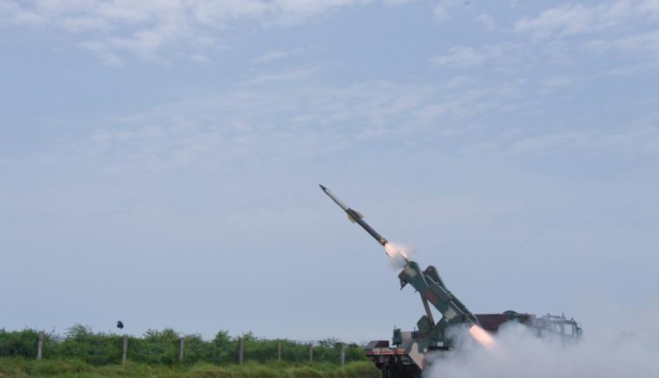

- The missile, tested in its deployment mode, intercepted a target in mid-air meeting successfully
- The entire launch was tracked by Range radar systems, ground telemetry systems and electro optical tracking system
- The QRSAM is the latest missile developed by DRDO along with Bharat Electronics Limited for the Indian army.
- In 2007, the proposal of QRSAM was launched as a replacement for Osa-AK and Kvadrat missile systems.
- The first testing of QRSAM was conducted in 2017 and the last test was conducted in August 2019

APPOINTMENTS
- The Centre - has named Harsh Vardhan Shringla, currently serving as India’s ambassador to the US, as the next foreign secretary.
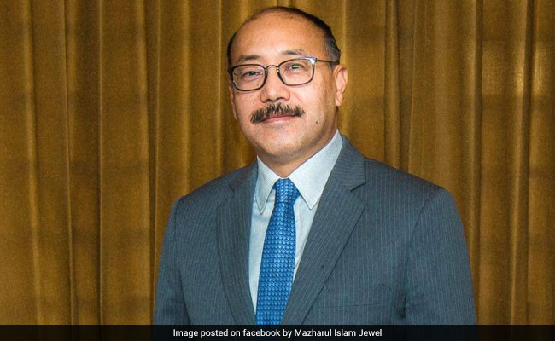
- Shringla, a 1984 batch civil services topper, is likely to take over on January 29 for a two-year tenure.
- Shringla will replace the incumbent, Vijay Gokhale, an expert on China and East Asia
- Gokhale succeeded S Jaishankar as foreign secretary in January 2018.
- Shringla has worked closely with S. Jaishankar when he was Foreign Secretary (2015-2018)
- S. Jaishankar was later appointed as External Affairs Minister by Prime Minister Narendra Modi in May 2019.
- Shringla is an alumnus of St Stephen’s College and Mayo College, Ajmer
- He took over as ambassador to Thailand (from 2014 to 2016) and High commissioner to Bangladesh, before serving as ambassador to the US
- He has also served at UNESCO in France, UN in New York besides Israel, South Africa and Vietnam.
- Having served earlier as Joint secretary in charge of Bangladesh, Myanmar, Sri Lanka, and the Maldives division, he has a deep understanding of the neighbourhood, which is of primary concern to the government.
- One of the landmarks of his career was the ‘Land Boundary Agreement’ for which he worked as a Joint Secretary during the UPA era

AWARDS
- Major Anoop Mishra - was felicitated with the Army Design Bureau (ADB) excellence award by Army chief Gen. Bipin Rawat
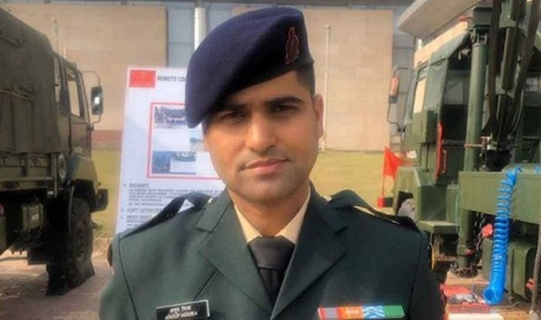
- He received the award for indigenously developing Sarvatra bulletproof jacket, which is designed to provide protection against various ammunition including sniper rifles
- The awards were conferred at Army Technology Seminar (ARTECH) held on 23 December 2019 in New Delhi
- ARTECH was based on theme - ‘Technologies for Non – Contact Warfare’
- Major Mishra is presently posted as Instructor at the College of Military Engineering, Pune.
- He was among the four awardees felicitated by Gen. Rawat.
- The project was sanctioned in June 2017
- The suit was named Sarvatra Kawach and it provides protection from neck to ankle and upper arms
NATIONAL DAY
- National Consumer Day – December 24

- The day underscores the importance of consumer movement and aims to make every consumer aware of their rights and responsibilities.
- Theme 2019 - ‘Alternate Consumer Grievance/Dispute Redressal’
- The day marks the enactment of the Consumer Protection Act, 1986, after receiving the assent of the president on this very day
- In 2019, Parliament gave its approval to replace age-old Consumer Protection Act, 1986 by passing landmark Consumer Protection Bill, 2019
- Upon receiving Presidential approval, the bill became the Consumer Protection Act, 2019 which aims to set up a Central Consumer Protection Authority (CCPA) that promotes, protects and enforces rights of consumers

