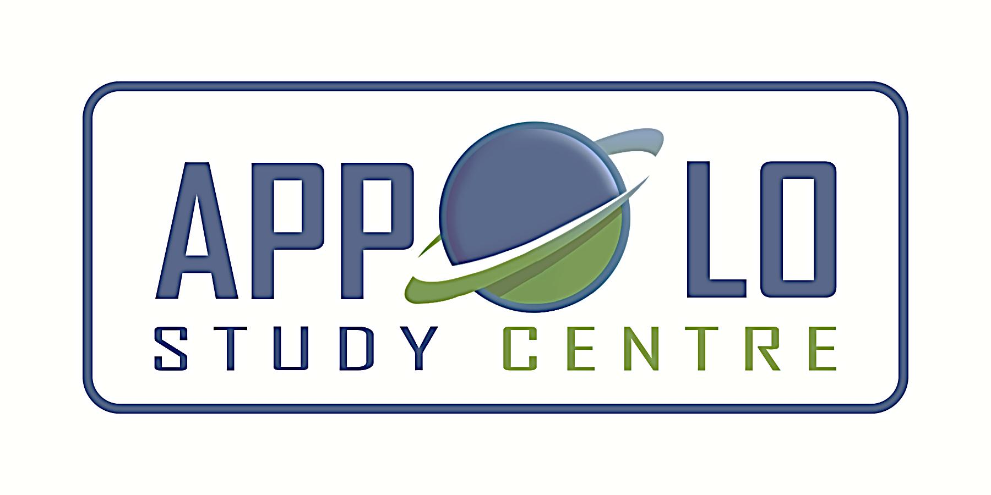
EVERYDAY CURRENT AFFAIRS – DEC 23, 2019

STATES
- Arunachal Pradesh - will soon have the government schools marked ‘hard’, ‘soft’ and ‘medium’ in the state
- The reasons for the categorization were cited as the geography, lack of infrastructure and reluctance of teachers to work beyond their comfort zones
- Under the new policy, all government schools in the state will fall into three categories — hard, medium and soft — based on topography, accessibility and degrees of difficulty in staying at the place of posting.
- All new recruit teachers will be given a ‘hard’ posting for a mandatory three years, inclusive of their probation period.
- The next five years will be in schools with levels of ‘medium’ difficulty, followed by posting in ‘soft’ schools
- Teacher absenteeism has been a major issue across 3,513 government schools, including 211 community schools, in the State.

- The Assam Cabinet – agreed to make Assamese language the state language of Assam.
- The move comes following the increase in insecurities among Assamese population in the state.
- The cabinet has also suggested making Assamese language ‘compulsory’ in all schools of Assam
- Currently Assamese and Bodo are the official languages in Assam.
- However, the move will exclude BTAD (Bodoland Territorial Administrative Districts), Barak Valley and Hill districts of Assam.
- Certain districts of Assam in Barak valley use Bengali as official language

NATIONAL

- Indian Railways’ premier coach manufacturing unit, Integral Coach Factory (ICF) - floated a new tender for procurement of electrical equipment and other items for 44 rakes of Vande Bharat Express
- Earlier known as Train-18, the Vande Bharat Express is the country’s first indigenously manufactured train-set, spearheaded by the ‘Make in India’ initiative
- The new ‘global’ competitive tender is related to the procurement of three-phase electrical propulsion system with other passenger-related and operator-related peripheral items
- The train will have the capability to reach a maximum speed of 160kmph in 140 seconds, thereby saving the running time by 20% due to its light weight body and improved acceleration.
- The specifications of the new design were approved by the Research Designs and Standards Organisation (RDSO)
- The optimised rakes would be suitable for operations in flood conditions and Jammu & Kashmir.
- All coaches in the new train-set would be chair car type, ideally suitable for day travel
- The train sets would be supplied in multiples of four coaches, which could be attached or detached from the train as per the requirement.
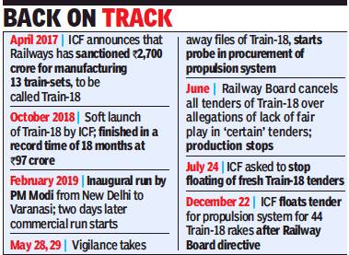
- ICF has so far produced two rakes of Train-18, which are in operation as the Vande Bharat Express on Delhi-Varanasi and Delhi-Katra route.
- The new tender is for the supply of 44 rakes of 16 coaches each
- The new train sets have been designed for faster, safer and more energy-efficient operations.
- On December 14, the Railway Board asked ICF to release a new tender for procuring the propulsion system towards the manufacture of 45 rakes of Vande Bharat Express that would be manufactured by 2021-22.

- The Railways - is looking to focus on increasing the average speed of passenger trains by over 30% to 80 kmph by 2024.
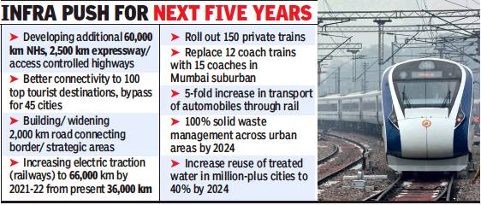
- It is also targeting a nearly 80% jump in speed of freight trains over the next four-and-a-half years - from the current 25 kmph to 30 kmph (2020-21), 34 kmph (2021-22), 39 kmph (2022-23) and 45 kmph by 2024
- The Railways is also planning to launch its new signalling system from April 2020 onwards, making the train travel faster and safer
- The implementation of the new system will begin with 4 sections of about 640 route kilometres at an estimated cost of around ₹1,810 crore.
- The four ‘high-traffic’ sections where the plan will be implemented first are the Renigunta -Yerraguntla section of the South Central Railways, the Vizianagaram-Palasa section of East Coast Railway, the Jhasi-Bina on North Central Railway and the Nagpur-Badnera on Central Railway.
- This will be the pilot project for pan-India implementation of the nearly ₹78,000 crore project to modernise the signalling system across the 70,000 km network of the Railways
- The modernisation will involve the implementation of technologies such as the Automatic train protection system that allows adherance to permissible speed limits without driver intervention and the 4G-based mobile train radio communication system, which can be used for emergency communications.

- ‘Chillai-Kalan’, the traditional 40-day period of harshest winter in Kashmir – begins on 21 December 2019
- This period is known for sub-zero temperatures, snow fall, frozen lakes and river
- It will end on 31 January 2020.
- Chillai-Kalan is followed by a 20-day-long period called ‘Chillai-Khurd’ (small cold) that occurs between January 31 and February 19
- This is followed by a 10 day period of ‘Chillai-Bachha’ (baby cold), which is from February 20 to March 2

- The Centre - launched EChO Network, a national program to boost cross-disciplinary leadership in India
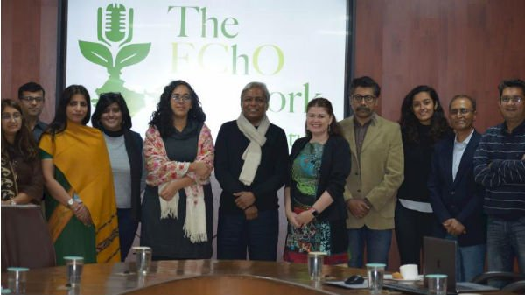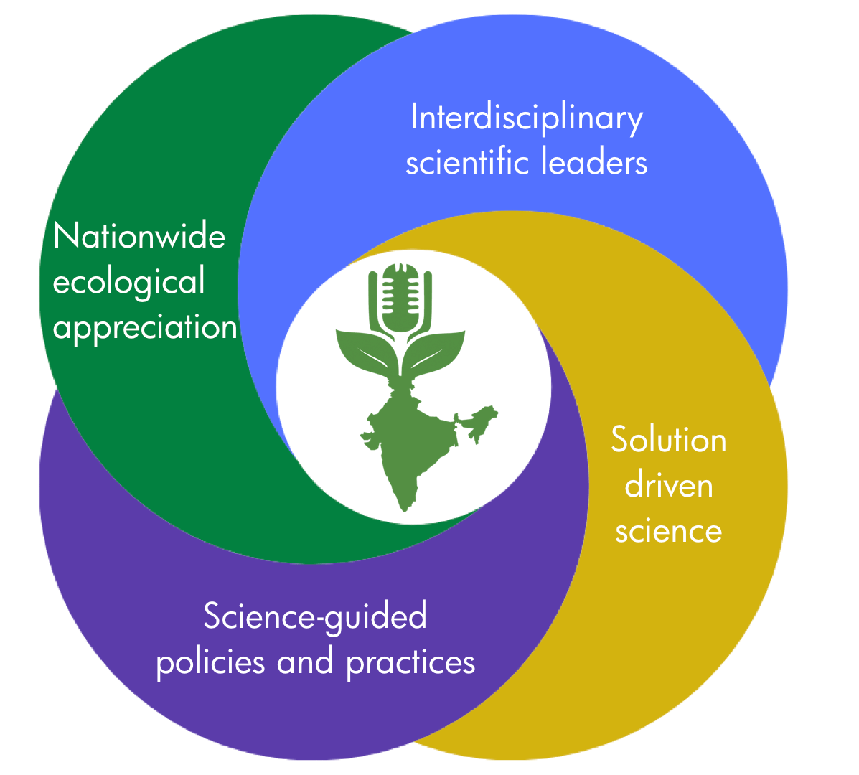
- The network specifically focuses on increasing research, knowledge, and awareness of Indian ecology and the environment
- It is the first-of-its-kind network in the world that will identify gaps in knowledge regarding selected topics in human and environmental ecosystems
- Bill and Melinda Gates Foundation, Centre for Cellular and Molecular Platforms (C-CAMP), Hindustan Unilever Limited (HUL), India Climate Collaborative (ICC), RoundGlass and Ashoka Trust for Research in Ecology and Environment (ATREE) are the founding partners of EChO Network
INTERNATIONAL
- Eight West African nations - have agreed to change the name of their common currency from ‘CFA franc’ to ‘Eco’ from 2020
- The 8 West African countries are- Ivory Coast, Mali, Burkina Faso, Benin, Niger, Senegal, Togo and Guinea-Bissau
- All these countries, except Guinea-Bissau, are former French colonies.
- The currency was seen as a sign of French interference in its former African colonies even after these countries became independent.
- CFA Franc has two types of currencies - ‘the West African CFA franc’, which is used in 8 West African countries, and ‘Central African CFA franc’, which is used in 6 Central African countries
- Both currencies are guaranteed by French treasury and were created in 1945.

INDIA AND NEIGHBOURS
- Bhutan - proposes to extend the mandatory “minimum daily package” of $250 (around ₹17,700) to regional tourists, those travelling from India, Bangladesh and Maldives
- This package is currently applicable only to foreigners.

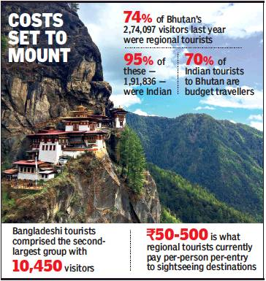

- The price includes a $65 “sustainable development fee” charged by the Government.
- However, visa charges, three-star accommodation, meals, intra-Bhutan transport, camping equipment and the services of a guide, travel operators will have to borne separately

SCIENCE, TECHNOLOGY & ENVIRONMENT
- Indian Space Research Organisation (Isro) – is planning 10 satellite missions, interplanetary mission Aditya L1 (sun) and first unmanned test-flight of the Gaganyaan mission carrying a humanoid in the year 2020.

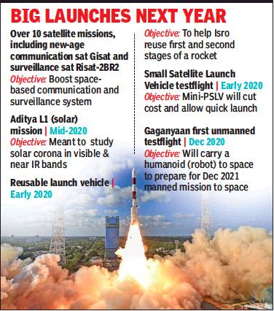

- The proposed launches will also include advanced communication satellites, Gisat1 and Gisat-12R and earth observation satellites, Risat-2BR2 and Microsat (for surveillance)
- The Aditya L1 mission will be the country’s first solar mission that will study the solar corona.
  - The 400kg-class satellite will be inserted in a halo orbit around the Lagrangian point 1 (L1), which is 1.5 million km from the Earth
  - The mission will carry six scientific payloads
  - The major advantage of the mission is to facilitate the continuous viewing of the Sun without any eclipse.
- The test-flight of Re-usable launch vehicle (RLV) and the first development flight of newly-developed Small Satellite Launch Vehicle (SSLV or mini-PSLV) are also likely to be launched by early next year
- The RLV technology will help Isro to reuse first and second stages of a rocket so as to cut cost and carry heavier payloads.
- The SSLV project is a vehicle-on-demand that will cater to half-a-billion-dollar small satellite market.
  - It can be assembled in just 3-5 days as compared to 40 days for a PSLV
  - It can carry a payload of up to 500kg to the low earth orbit, making it ideal for launching small satellites.
- Isro will try to launch the first test flight of the Rs 10,000cr Gaganyaan mission by the end of 2020.
- A modified GSLV MKIII will carry a humanoid (a robot with human features) in a human capsule to space in the next year.
- The first test-flight will be followed by a second unmanned mission in July 2021
- Then, the final human spaceflight mission is scheduled in December 2021 in which three astronauts will be sent to space for 5-7 days for performing various experiments in space.
- The astroanuts, enclosed in a crew module attached to a service module, will finally be fly back to the Earth after a week in space.

- Ethiopia - launched its first satellite, ‘Ethiopian Remote Sensing Satellite’ (ETRSS) from China.
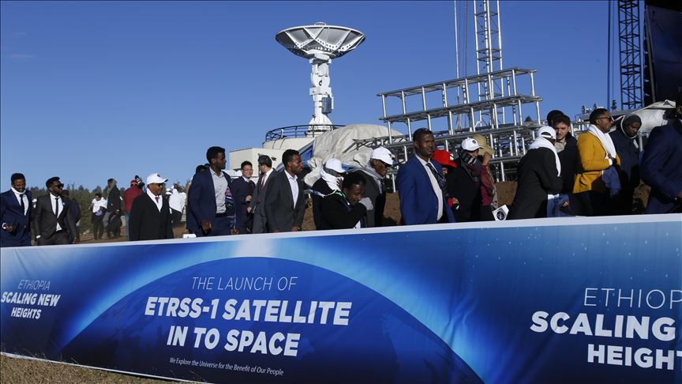
- ERSS is a remote-sensing microsatellite which will help the research into climate change.
- It can also provide remote-sensing data for agriculture, forestry, water conservation, as well as disaster prevention and mitigation.
- With the launch, Ethiopia becomes the 11th African country to put a satellite into space
- Egypt was the first country in Africa to launch a satellite into space in 1998.

DEFENCE
- The Officers Training Academy (OTA) in Gaya - is being shut down as it is not used to its full potential

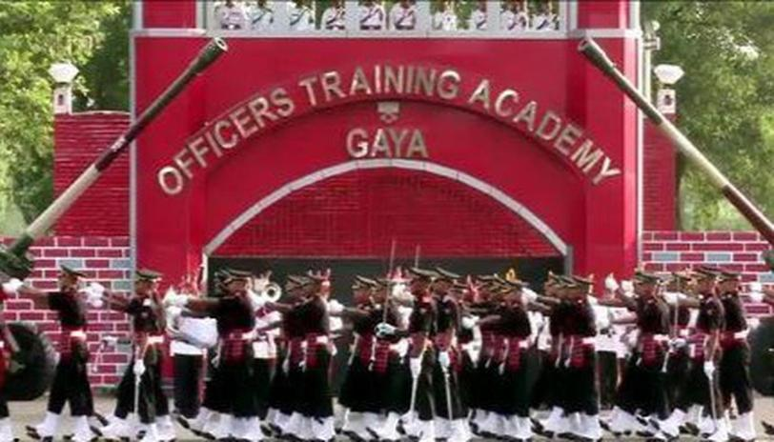
- The Sikh Light Infantry Regimental Centre, which is short of space at Fatehpur in Uttar Pradesh, will shift into the premises of OTA in Gaya
- The OTA, Gaya, was set up in 2011.
- The officer cadets at OTA, Gaya will be trained at the Indian Military Academy, Dehradun.
- Presently, the Rajput and Sikh Light Infantry Regimental Centres are located at Fatehpur
- Once the Sikh Light Infantry Regimental Centre moves to Gaya, the Rajput regiment will occupy the entire premises at Fatehpur.
- Regimental Centres require a large parade ground for training and other facilities, which are readily available in Gaya
APPOINTMENTS
- Manuel Marrero Cruz – is announced as the first prime minister of Cuba in more than last 40 years
- His appointment will be for a period of five years
- Before the announcement by Cuban President Miguel Diaz-Canel, Cruz served as Cuban tourism minister for 16 years.
- The prime minister will be managing day-to-day operations but will still report to president.
- The post of prime minister was scrapped in December 1976 by the then-revolutionary leader and Cuba’s last Prime Minister, Fidel Castro.
- Cuban voters approved a new constitution in February 2019 to replace 1976 Soviet-era charter enacted under Fidel Castro, bringing back the position of Prime Minister and Deputy Prime Minister
- But still, under the new constitution, the Communist Party still remains the only political party allowed in Cuba
NATIONAL DAY
- National Farmers Day - December 23
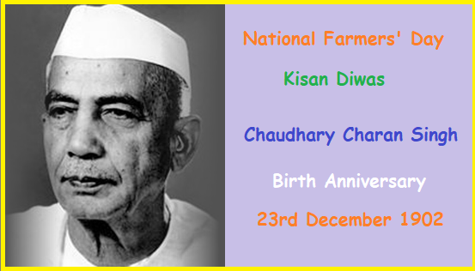

- The day marks the birth anniversary of former Prime Minister of India, Chaudhary Charan Singh
- Chaudhary Charan Singh was also known as a farmer’s leader.
- The Government announced to celebrate the day as Farmers Day in 2001.
- The day is widely celebrated in states such as UP, Haryana, Punjab and MP.
- Chaudhary Charan Singh’s hard work was responsible for the passing of ‘Zamindari Abolition Bill-1952’
- Chaudhary Charan Singh became the first non-congress CM of UP
- He was the Prime Minister of India from 28 July 1979 to 14 January 1980
- He has written several books, which includes Abolition of Zamindari, India's Poverty and Its Solutions and the Legend Proprietorship.
- In 1979, the National Bank for Agriculture and Rural Development (NABARD) was established during his tenure.
- His memorial known as ‘Kisan Ghat’ is located in New Delhi.

- National Mathematics Day – December 22
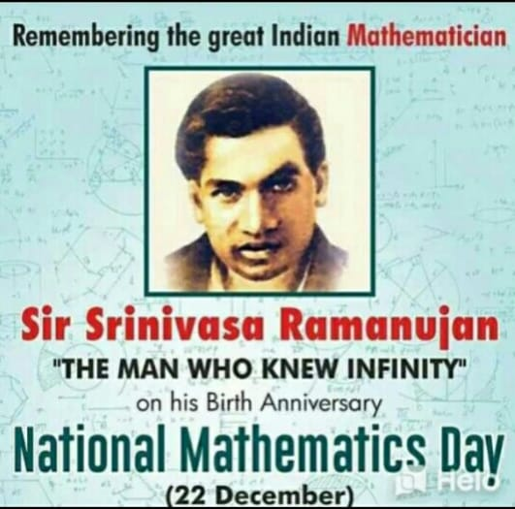
- The day marks the birth anniversary of Mathematics genius, Srinivasa Ramanujan
- Ramanujan is famous for his contributions to number theory, mathematical analysis, infinite series and continued fractions.
- He was born on 22 December 1887 in Tamil Nadu’s Erode district
- In his short life of 32 years, he discovered his own theorems and compiled as many as 3900 mathematical results and equations independently.
- He discovered the Hardy-Ramanujan number- ‘1729’ along with British Mathematician G.H. Hardy
- It is the smallest number which can be represented as sum of two different cubes in two different ways.
- In 2012, the Central Government under the then Prime Minister Dr. Manmohan Singh, declared 22nd December as ‘National Mathematics Day’ to celebrate 125th birth anniversary of Srinivasa Ramanujan.
- The year 2012 was also declared as National Mathematics Year.

