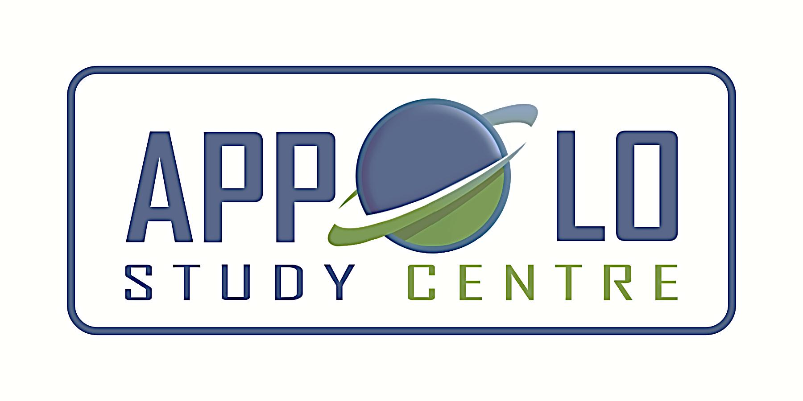
EVERYDAY CURRENT AFFAIRS – DEC 21 & 22, 2019

TAMIL NADU
- The Neyveli Lignite Corporation (NLC) - commissioned two power units on December 19 with 500 MW capacity each, using lignite mined in the region as fuel
- It is the first instance in the country that thermal units with a capacity above 250MW and using lignite as fuel have been commissioned.
- With the new units, the total thermal capacity of NLC India Ltd now becomes 5,000 MW
- Tamil Nadu, Kerala, Karnataka, Andhra Pradesh, Telangana and Puducherry will be receiving the power from this plant.
- Currently, NLC supplies around 1,300MW of power through its various thermal units

- The Public Health Department - has planned to distribute de-worming tablets (albendazole) to everyone free-of-cost in Tamil Nadu, instead of just children
- The pills will be issued twice every year for at least five years from February 2020.
- The drug will get rid of parasitic worms in the body and deworming will bring down soil-transmitted helminth infections caused by various parasites such as roundworm, hookworm and whipworm
- These infections affect the nutritional status of the infected people as worms feed on host tissues, mostly blood, causing iron and protein loss.
- Hookworms cause chronic intestinal blood loss, resulting in anaemia, as the worms can suck up to 0.2ml blood per day
- Necator americanus is one of the common species of worms in Tamil Nadu
- Anaemia is also one of the leading causes of maternal death in the state

- The World Bank – to offer nearly ₹5,500 crore to Metro Water for taking up four projects that will improve water supply and sewage treatment in Chennai.
- The first project is to lay an underground sewage system in the newly-added areas of Greater Chennai Corporation
- The second project is to set up a tertiary sewage treatment system, under which grey water from across the city will be tertiary treated with ultra filtration technology
- The third project is to execute the ‘Illamthorum inaippu’ scheme, which is meant for those added areas where underground sewage connections are in place.
- The fourth project is to strengthen and improve water distribution network in the core areas of Chennai city
- The underground sewage system for the extended areas is set to receive a sum of ₹1,900 crore, while the sewage treatment project is allotted a budget of ₹1,800 crore. ‘Illamthorum inaippu’ scheme has been allocated ₹950 crore and water supply enhancement ₹850 crore.
- The World Bank had agreed to fund the projects under the Chennai Water Supply Improvement and Transportation Network under the Chennai City Partnership Water Resilience and Urban Governance Mission.

- The Integral Coach Factory - retained its position as the largest coach- maker in the world as on December 20
- On December 20, it had rolled out its 3,000th coach in 215 days for 2019-2020, beating its own record set in 2018-19
- The country’s premier production unit took 289 days to make 3,000 coaches in 2018-19.
- Established in 1955, it made the first air-conditioned coach in 1966 and commenced export of bogies to Thailand the next year.
- The ICF took the same time (217 days) to roll out just 1,000 coaches in 2014.
- A majority of the 3,000 coaches made this year were the Linke Hofmann Busch (LHB) variant built on German technology.
- In 2017, the ICF made four popular coaches for Indian Railways — Tejas, Anubhuti, Deenadayalu and Antyodaya.
- In the year 2018, Train18, built indigenously in a record 18 months at a cost of ₹ 98 crore, was rolled out marking a significant event in its entire history
- Train 18, later flagged off by Prime Minister Narendra Modi as Vande Bharat Express, is considered as the most successful product of the ‘Make in India’ initiative.
- The Ministry of Railways recently asked the ICF to develop 45 rakes for Vande Bharat Express in the next two years.

- Tamil Nadu - has emerged at the top in coverage of area under micro-irrigation (MI) this year.
- Of about 3.64 lakh hectares brought under MI in the entire country, Tamil Nadu accounts for around 1.39 lakh hectares, accounting for 38% of the total coverage in the country
- These details are provided by Pradhan Mantri Krishi Sinchayee Yojana, a Central scheme aimed at improving on-farm water use efficiency through a number of measures such as MI and DI (drip irrigation)
- Gujarat comes next with a coverage of 77,858 hectares and Andhra Pradesh at third position with 52,027 hectares.
- Maharashtra comes fourth with around 36,831 hectares and Uttar Pradesh at fifth with 25,680 hectares.
- This year, the focus is on drip irrigation, which will ensure greater degree of water saving than sprinkler.
- The Central government has also sanctioned the installation of 17,500 solar agricultural pumpsets in the State.
- This has been done under the Pradhan Mantri Kisan Urja Suraksha evem Utthan Mahabhiyan (PM-Kusum) scheme of the Centre.
STATES
- Rajasthan CM Ashok Gehlot - launched first Janta Clinic in Jaipur.
- These clinics provide free medicines and also free of cost medical tests.
- Each clinic will have a staff of six people and costs around 6 to 8 lakh rupees per month to the state’s exchequer
- About 12 places have been finalized in Jaipur for such Janta clinics.

- Odisha Chief Minister Naveen Patnaik - launched the 'Jalasathi' programme and its App on December 18
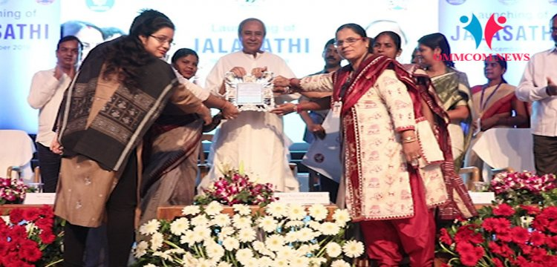
- The initiative aims to ensure supply of safe drinking water to all households through piped water connections in the state.
- The Water Corporation of Odisha (WATCO) signed a MoU with the women federations in Bhubaneswar for the implementation of the programme
- The Odisha government will be utilizing the services of women volunteers to serve the people as 'Jalasathis'.
- The Jalasathis will be responsible for testing of water quality through special kits, facilitating new water connections and regularising connections, reassessing of demands, reading of meter, bill generation and delivery, collection of water charges through PoS machines and facilitating complaints redressal.
- The Odisha state government had earlier engaged the women self-help groups for collection of power dues, paddy procurement and mid-day meal preparation activities under its 'Mission Shakti' scheme.

NATIONAL
- The Centre - has launched National Broadband Mission (NBM) with an aim to provide an internet connection to all villages by 2022
- Union Minister of Communications Ravi Shankar Prasad inaugurated this mission
- A budget of Rs 7 lakh crore will be invested in the mission
- The government will ensure to install an additional optical fiber cable route of 3 million kilometers.
- The National Broadband Mission was first conceived by Prime Minister Narendra Modi in his independence day speech from Red Fort this year
INTERNATIONAL
- The United States – announced the creation of a full-fledged US space force within the Department of defence.
- President Donald Trump initiated the creation of the Space Force with the signing of the 2020 National Defence Authorisation Act
- The Act allocated the initial budget for a new Pentagon force that will be on par with the military's five other branches.
- The Space Force will be the sixth formal force of the US military, after the Army, Air Force, Navy Marines, and Coast Guard.
- Like the Marines, which operate within the umbrella of the Navy, the Space Force will continue to operate under the Air Force.
- The Space Force will be equipped with 16,000 air force and civilian personnel, with some already taking part in the Space Command
- The move follows the recent reports that China and Russia have both developed “robust and capable” space services for intelligence, surveillance and reconnaissance
- China already demonstrated its capability to shoot down a satellite with a ground-based missile in 2007

- The UK – is all set to leave the European Union by January 31, 2020.
- Prime Minister Boris Johnson’s Brexit bill was cleared by the House of Commons
- It has voted 358 to 234 in favour of the government’s EU Withdrawal Agreement Bill
- The bill calls for ban on the extension of the transition period of Brexit beyond 2020
- Britain had earlier voted to exit the EU in a June 2016 referendum
- Over 17 million people, out of total 30 million, voted for the Brexit.
- Brexit was initially scheduled to take place on March 29, 2019, which was later pushed to October 31, 2019
- If Brexit comes into force, UK would become the first member state to leave the EU.
DEFENCE
- India – to sign the $930 million deal with the US for six AH-64E Apache attack helicopters for the Indian Army by early next year
- These are in addition to 22 Apaches being inducted by the Indian Air Force
- The helicopters should start coming in by 2022
- In August 2017, the Defence Acquisition Council, chaired by the then Defence Minister Arun Jaitley, approved the purchase of six Apache attack helicopters from the U.S.
- The IAF has recently inducted the first batch of eight Apaches based in Pathankot.
- All the 22 Apaches are expected to be delivered by 2020
- They are expected to replace the ageing Russian Mi-35 attack helicopters in service.
- Currently, the Army Aviation Corps is operating only smaller Cheetah and ALH (Advance Light Helicopters) that weigh less than five tonnes.

- India - successfully conducted test firing of the indigenously developed Pinaka missile system on December 20 from the Integrated Test Range at Chandipur off the Odisha coast
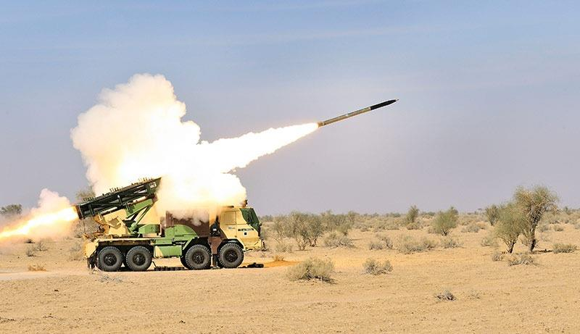
- The missiles were fired for a second successive day, which have engaged a target located at 20-kilometre range with high accuracy
- The Pinaka Mark-2 is capable of firing 12 rockets in just 44 seconds
- The Pinaka missile system has been equipped now with an advanced guided line system, thereby increasing its firepower and accuracy.
- It was developed by Defence Research and Development Organization, jointly in association with Pune's Armament Research and Development Centre, ARCI and Hyderabad's Defense Research and Development Laboratory.
- The missile's navigation system is supported by the Indian Regional Satellite System (IRNSS), also known as NAVIC.

ECONOMY
- The Digital Communications Commission (DCC) - approved plans to auction over 8,300 MHz of spectrum with a reserve price of ₹5.22 lakh crore.
- The airwaves will be put to bid in March/April 2020.
- Out of the 8,300 MHZ of airwaves, 6,050 MHZ are allocated for 5G services.

APPOINTMENTS
- US President Donald Trump - has proposed to nominate Indian-American engineer-scientist Dr Sethuraman Panchanathan as Director of the National Science Foundation (NSF)

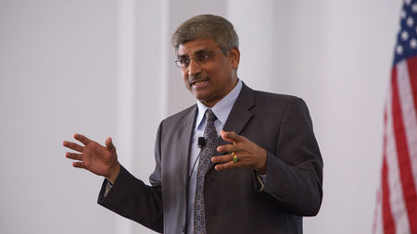
- The nomination of Panchanathan, a graduate of Indian Institute of Science (1984) and Indian Institute of Technology (1986), will have to be approved now by the Senate
- The NSF is the US government’s foremost funding agency that supports basic research and education in all the nonmedical fields of science and engineering, with a budget allocation of nearly $8 billion
- Panchanathan is the founding director of the Centre for Cognitive Ubiquitous Computing at Arizona State University
- He is currently serving as the university’s executive vice-president and the Chief research and innovation officer.
- Chennai born IITian, Dr Panchanathan is the second Indian-American to head the prestigious 70-year old foundation
- Earlier Dr Subra Suresh, another Chennai-born IITian, was nominated to lead NSF in 2010
- Although the period of directorship is for a six year term, Dr Suresh left after three years.
- The outgoing NSF director Dr. France A. Cordova has just concluded her six-year term.
- The NSF funds approximately 24% of all federally supported fundamental research conducted by colleges and universities in US.
- In some fields, such as mathematics, computer science, economics, and the social sciences, the NSF is considered as the major source of federal backing.
SPORTS
- The government - launched ‘one state, one game’ initiative to bag more medals in 2020 Tokyo Olympics
- The initiative, launched in consultation with state governments, helps to make a state proficient in a single sport in which it has chances for winning an Olympic medal in that discipline
- The government has also identified 14 sports disciplines to be developed as medal prospects for the 2024 and 2028 Olympics
- Archery, boxing, shooting, badminton, wrestling, hockey, weightlifting, cycling and athletics have been identified as medal prospects for Olympics 2024
- For 2028 and beyond, table tennis, judo, swimming, fencing and rowing will be included.
- The central government will provide the funding to each state for each sport, to create exclusive ‘centres of excellence’ in every related state

- Youth Olympic gold medallist weightlifter Jeremy Lalrinnunga - claimed three world record marks in the men's 67kg category at the 6th Qatar International Cup at Doha
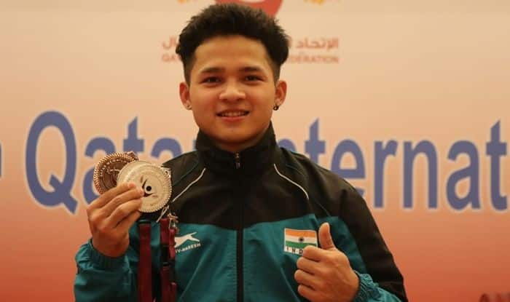
- The 17-year-old smashed his own Youth World and Asian record in snatch, clean and jerk and total lift with an effort of 306kg (140kg+166kg) to win the silver medal
- Jeremy broke 27 records till now, combining national and international marks.
- Overall, he had smashed 12 international records — three youth world, three youth Asian and six Commonwealth records — and 15 national records.

- Saikhom Mirabai Chanu - won the gold in the women’s 49kg category at the sixth Qatar International Cup weightlifting championships at Doha
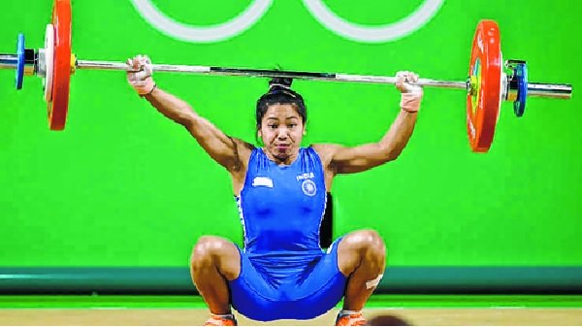
- The 25-year-old Chanu secured the top spot with an effort of 194kg in the Olympic qualifying silver-level event
- The 2018 Commonwealth Games gold-medallist Chanu managed to register only one clean lift in both the snatch and clean and jerk categories.
- Chanu achieved her personal best of 201kg during this year’s World Championships in Thailand.

