EVERYDAY CURRENT AFFAIRS – march 2, 2022
-

TAMIL NADU
- On March 1, Chief Minister M K Stalin - launched an ambitious new initiative titled “Naan Muthalvan”

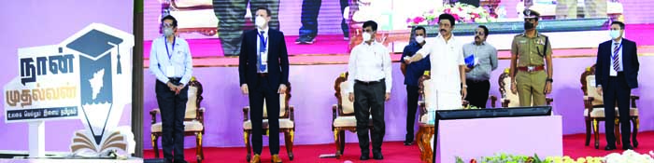

- The flagship scheme is a massive skilling and career guidance programme for school and college students in the state.
- The initiative aims to improve the educational skills, knowledge, talent, and efficiency of 10 lakh students every year besides bridging the talent gap in the employment market
- The scheme's launch coincided with the Tamil Nadu CM's birthday and the scheme will be directly supervised by the chief minister
- Under the scheme, efforts will be made to include training students on their choice of subjects/areas, languages, technical knowledge and so on
- During his speech, the CM said each school will have a career guidance centre to guide students on what to study and where to study, while colleges will provide guidance on skills needed for jobs.
- The school education department will prepare a separate curriculum for conducting career guidance classes for students of Class IX to XII.
- The state government will conduct coding and robotics classes for school students and organize summer camps as well as professional counselling on issues such as physical health and behavioural issues
NATIONAL
- On March 1, Prime Minister Narendra Modi - asked the Indian Air Force (IAF) to join ‘Operation Ganga’ to evacuate Indians from the war-torn country.
- The IAF will join the operation from the early hours on March 2 with its C-17 Globemaster-III aircraft
- The IAF’s support will supplement Air India’s ongoing effort to evacuate stranded Indians.
- The first C-17 will leave for Romania, with others to follow it later.
- The IAF has been keeping its C-17 and C-130J Super Hercules aircraft on stand-by for the evacuation from Ukraine for the last few days.
- These aircrafts were extensively used to airlift Indians stranded in Afghanistan after the Taliban takeover in August last year
- Over 8,000 students are still stuck in Ukraine after over 12,000 were evacuated.
- According to government, there is no Indian left in Kyiv and more than 60% of the Indian nationals had reached destinations out of the war zone.
- Till now, only private Indian carriers have been evacuating Indians from Romania and Hungary, countries with land borders with Ukraine on the western side, as the Ukrainian airspace has been shut since February 24.
- The government said the large C-17 aircraft will also help deliver humanitarian aid to war-hit Ukraine more efficiently.
- Indians are travelling by road to Ukraine’s borders with Romania, Hungary, Slovakia and Poland from where they are being taken by the Indian government officials to the airports for the evacuation flights.
- Four Union ministers — Hardeep Singh Puri, Jyotiraditya Scindia, Kiren Rijiju and Gen (retd) V K Singh— left for these countries to oversee the evacuation efforts.
- The IAF acquired 11 C-17s from the US for over $4.5 billion over the last decade.
- Meanwhile, other Indian carriers — including Air India, AI Express, IndiGo and SpiceJet — will operate mainly to Bucharest and Budapest.

- Naveen Shekharappa, the 21-year-old MBBS student in Kharkiv - lost his life on March 1 in Kharkiv, Ukraine to become the country’s first casualty in the ongoing war

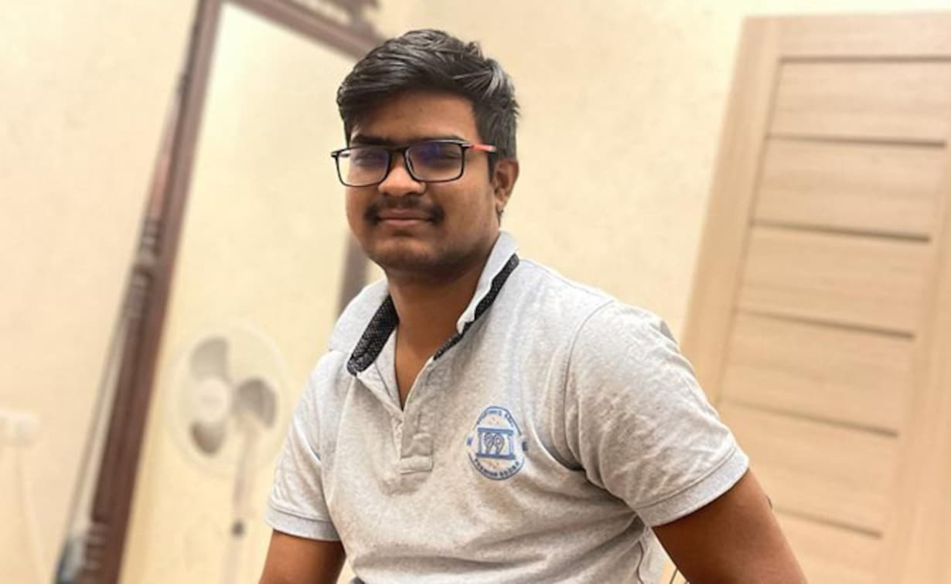

- Naveen was standing in the queue for food in Ukraine's second largest city, Kharkiv, when he was killed in an intense Russian shelling
- Hailing from Karnataka’s Haveri district, Naveen was a final year medical student at the Kharkiv National Medical University.
- The death prompted the external affairs ministry to demand that Russia and Ukraine take immediate steps to ensure safe passage for Indian students who are trapped in the country.
- Estimates of the total number of Indian students in Kharkiv range from 2,000 to 4,000
- Kharkiv is located barely 40 km from the Russian border and has witnessed intense hostilities over the past few days
- Meanwhile, Foreign Secretary Harsh Vardhan Shringla said that all Indian nationals in Ukraine’s capital Kyiv have been evacuated.
- On February 15, the Government issued its first advisory urging Indian nationals to consider leaving Ukraine temporarily.
- Since then, around 12,000 of the estimated 20,000 Indians in Ukraine have left that country, including those brought back under the evacuation effort titled Operation Ganga.
HIGH COURT VERDICT
- On March 1, the Madurai Bench of Madras High Court - ordered action against any government teacher running private tuition centre, engaged in private business or part-time employment
- The Madras high court has ordered the principal secretary of the education department to form district-level teams to investigate and take action against teachers involved in misconduct.
- The court observed that there is a deterioration of education in government schools and added that the government schools are not on par with the private schools in the state
- It has directed the education department to set up telephone numbers to help parents, students and public to register complaints and flag misconduct and irregularities by teachers.
- The court ordered that such contact numbers must be legibly displayed in all education department offices and government and aided schools in the state
- The judge further directed the principal secretary to collect information, complaints, materials regarding activities of the recognized / registered teachers’ associations in the state to ensure that they are functioning according to the statutes and rules in force.
- Justice Subramaniam, while delivering the verdict, observed that the activities of these associations are to be monitored by the government.
- The court was hearing a plea moved by a government school teacher against the dismissal of her request for transfer to another district.
PERSONALITIES
- Former Turkish Airlines Chairman Ilker Ayci - has declined Tata Sons' offer to be the new chief executive officer of Air India

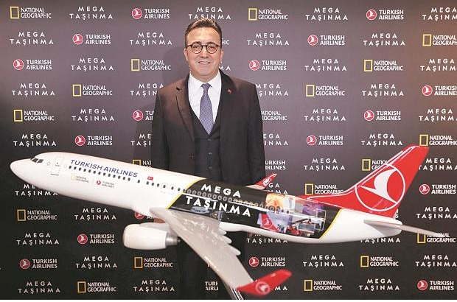

- In a detailed statement, Ayci said that media reporters tried to colour his appointment with ‘undesirable colours.’
- Soon after the announcement of Ayci’s appointment, allegations of his connections to the terrorist organization Al-Qaeda appeared in the media
- Tata Sons is expected to name a new CEO in the coming days.
- Till then, Tata Sons and four board members of the carrier will run operations.
- Ayci's appointment to head Air India was confirmed by Tata Sons on February 14, and he was to join the airline on or before April 1, 2022
- Ayci, who was born in Istanbul in 1971, was also an adviser to Turkish President Recep Tayyip Erdogan when he was mayor of Istanbul from 1994 to 1998.
- Notably, the Turkish President is a close supporter of Pakistan and often stands against India on the International platform.
- Ayci was later appointed as the chairman of Turkish Airlines in 2015 and had resigned from the post in January 2022.
- Ayci, who was the former chairman of the Turkish Investment Support and Promotion Agency (ISPAT), had promoted private investments and ventures by Yasin al-Qadi, the former alleged Al-Qaeda financier
- Turkey is currently in the Grey List of Financial Action Task Force (FATF), just like Pakistan, over the allegations of terror funding.
- Under Ayci’s management, Turkish Airlines moved to its new hub in Istanbul, which is set to be the world’s largest airport when fully completed in 2023.
OBITUARY
- On March 1, tech giant Microsoft - announced that its chief executive officer Satya Nadella’s son Zain Nadella, who was born with cerebral palsy, has died.

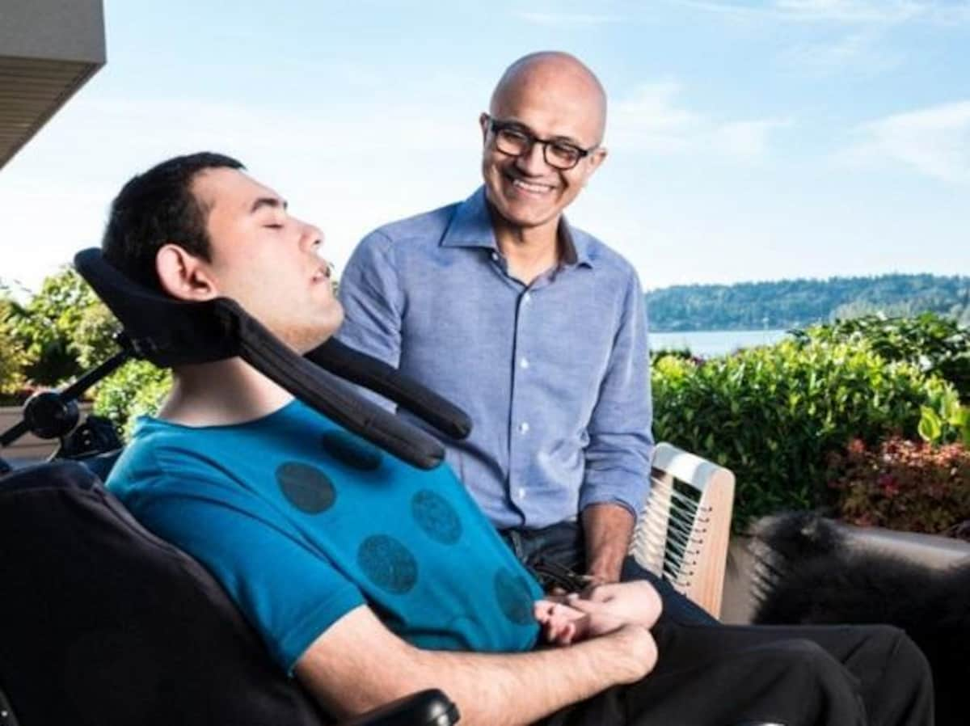

- Nadella’s son was born on August 13, 1996, after his wife Anu during her thirty-sixth week of pregnancy noticed that the baby was not moving as in a normal situation.
- Nadella in a blog in 2017 mentioned that Zain did not cry at the time of birth and had to be shifted to a hospital in Seattle with a state-of-the-art Neonatal Intensive Care Unit.
- Nadella had said he learnt that damage caused by utero asphyxiation caused severe cerebral palsy in his child.
- He also wrote that as a father of a son with special needs was the turning point of his life and helped him better understand the journey of people with disabilities.
- Since taking on the CEO’s role in 2014, Nadella has focused the company on designing products to better serve users with disabilities and cited lessons he learned raising and supporting Zain.
- Last year, the Children’s Hospital, where Zain received much of his treatment, joined with the Nadellas to establish the Zain Nadella Endowed Chair in Pediatric Neurosciences, as part of Seattle Children’s Center for Integrative Brain Research.
- Hyderabad-born Nadella was named CEO of Microsoft in February 2014.
- In June 2021, he was named as the company’s chairman.
SPORTS
- Pistol shooter Saurabh Chaudhary – clinched the men’s 10m air pistol title at the ISSF World Cup in Cairo on March 1

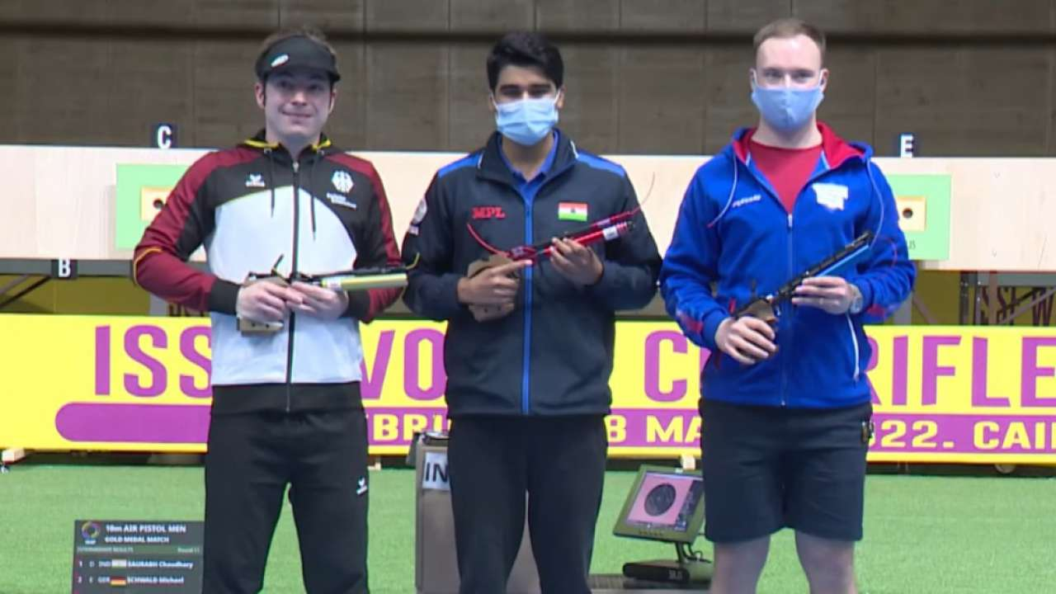
- The World Cup is following the new format brought in practice by the International Shooting Sport Federation (ISSF).
- As per the new format, top eight shooters in the qualifying stage (60 shots) make the cut for two semifinals.
- In the semifinals (four shooters each), top two shooters from each semifinal qualify for the medal round, where medals are decided as per the ranking of shooters.
- In the gold match, Saurabh defeated Germany’s Michael Schwald 16-6.
- Russia’s Artem Chernousov finished third (40 points) in this round to win bronze.
- Following International Olympic Committee’s instruction, the ISSF, headed by Russia’s Vladimir Lisin, removed Russia’s name from the medals tally.
- Russian shooters didn’t have their country’s name in front of them.
- Tokyo Olympics silver medallist and reigning world champion Chernousov, who won bronze in the men’s 10m air pistol event, was registered as an independent participant.
- Meanwhile, India’s Esha Singh clinched silver in the women’s 10m air pistol event after losing 16-6 to Korakaki in the gold medal round.

- On March 1, Russian athletes - were barred from all competitions by World Athletics over Russia’s invasion of Ukraine
- According to World Athletics, all athletes, support personnel and officials from Russia and Belarus will be excluded from all World Athletics Series events for the foreseeable future, with immediate effect
- Upcoming events include the World Athletics Championships Oregon22, the World Athletics Indoor Championships Belgrade 22, and the World Athletics Race Walking Team Championships Muscat 22, which begin on March 4 in Oman
- More sporting bodies sanctioned Russian and Belarusian athletes on the day over Russia’s invasion of Ukraine
- The governing bodies for badminton, rowing and skiing banned athletes from the two countries from international competition.
- The BWF move comes a day after it cancelled tournaments in Russia and Belarus.
  - The BWF said the ban on athletes and officials from Russia and Belarus would start at the German Open from March 8-13
- In another development, the International Hockey Federation barred Russia from taking part in the upcoming FIH Women’s Junior World Cup.
  - The World Cup is scheduled to be held in Potchefstroom, South Africa from April 1 to 12.
- Earlier, Russia has been stripped of hosting the men’s Volleyball World Championships in August and September

